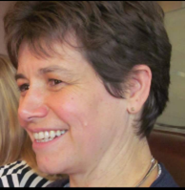
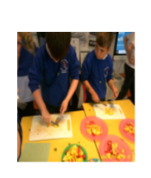

Venford Class Blog
Venford has had a very busy first half term! I’m so pleased with how quickly the children settled into Year 1 and how well they’ve coped with the transition from Meldon Class.
We have enjoyed listening to lots of different stories, especially Cave Baby and How to Wash a Woolly Mammoth, which we used as inspiration for our writing. We’ve been focusing on saying our sentences out loud before writing, remembering to leave finger spaces between words, and beginning sentences with capital letters and ending them with full stops. We’re also working hard on our number and letter formation.
In Science, we’ve been investigating our five senses. We explored our sense of touch with a feely box, identified different smells in pots, listened and identified different sounds, used our sense of sight to find items in various colors around the class, and explored different tastes in our Design and Technology lessons.
In Design and Technology, we made healthy smoothies! First, we learned the difference between fruits and vegetables and tasted various types to decide our favorites. We practiced cutting them carefully and then made our smoothies, which we loved tasting! We later wrote instructions on how to make them, using our English skills.
In Geography, we learned about where we live. We know that we live in Europe and enjoyed learning a song about the continents to help us remember them. Continents Song
We also learned about the United Kingdom and the countries that make up the UK, with another catchy song to help us. UK Song
Afterward, we focused on where we live in Devon, specifically the area around Buckfast where we go to school. We took a walk around the school to observe our local surroundings, then drew maps of the area, including everything we passed along the way.
We were also very fortunate to meet Father Francis at Buckfast Abbey. He showed us around the Blessed Sacrament Chapel and explained some of the special vessels used in Mass such as the chalice that holds the wine and the paten that holds the bread. We then took part in a very special Harvest Mass where we celebrated all that we have and said thank you to God.
I’m looking forward to next half term and all the new things we’ll discover together in the coming weeks!
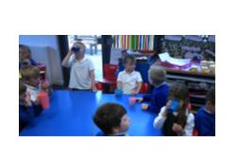
Always remember, the door is open morning and evening if you want to pop in and chat or find out more about our learning in Venford.
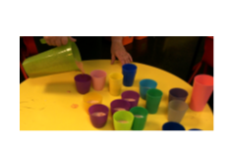
Mrs Hutchinson

