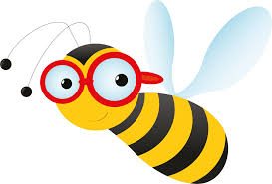
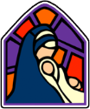
St Mary’s Science Rolling Programme
Plan Bee Scheme

 |  | Autumn 1 |  | Autumn 2 | Spring 1 | Spring 2 | Summer 1 | Summer 2
Meldon  EYFS |  | Our Bodies  Seasons - Autumn |  | Seasons - Winter | Materials | Floating/Sinking  Dinosaur Fossils  Seasons – Spring | Plants and Minibeasts | Animals
Venford  Year1 |  | Seasonal Changes |  | My Body – Humans | Materials | Seaside Objects | Identifying Plants | Identifying Animals
Avon  Year 2 |  | Growth and Survival |  | Exploring Everyday Materials | Super Scientists | Growing Plants | Living in Habitats
Roadford  Year 3 |  | Rocks, Fossils and Soils |  | Health and Movement | Forces and Magnets |  | Light and Shadow | How Plants Grow
Fernworthy  Year 4/5 | A | Circuits and Conductors (4) |  |  | States of Matter (4) |  | Living in Environments (4)
Fernworthy  Year 4/5 | B | Eating and Digestion (4) |  |  | Earth and Space (5) | Changing Sound (4) | Life Cycles (5)
Burrator  Year 5/6 | A | Properties and changes of materials (5) |  |  | Evolution and Inheritance (6) |  | Forces in Action (5) | Changing Circuits (6)
Burrator  Year 5/6 | B | Seeing Light (6) | Earth and Space (5) |  | Classifying Organisms (6) |  | Healthy Bodies (6) | Changes and Reproduction (6)

