

s
EYFS Long Term Planning Year A

 | Autumn Term |  | Spring Term |  | Summer Term
Over Arching Theme | The World Around ME!   |  | A World of Imagination  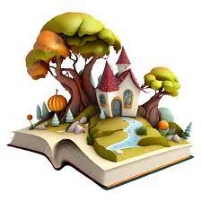 |  | 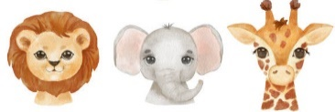  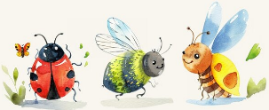  Bugs to Beasts
Focus Topics | Me & my family  My Local Area  Community Jobs  Autumn | Autumn  Remembrance  Transport / Space  Winter/Christmas | Traditional Tales  Pancake Day  Chinese New Year | Pirates  Dinosaurs  Spring | Plants  Minibeasts | Animals (Farm, African, Jungle, Sea, Polar)
Focus Texts |   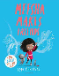  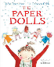  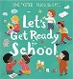  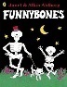  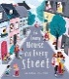  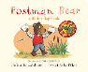 |     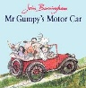  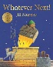    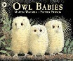 | 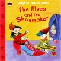  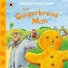    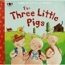  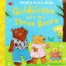 | 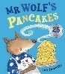  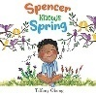  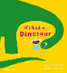  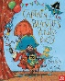    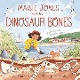 |   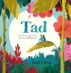  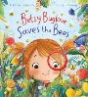     |   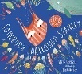  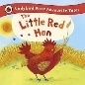  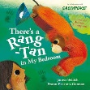  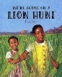  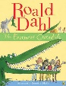  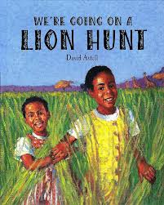  r
Little Wandle Phonics | Phase 2  s, a, t, p, I, n, m, d, g, o, c, k, ck, e, u, r, h, b, f, l  Tricky Words  I, a, is, as, the | Phase 2  ff, ll, ss, j, v, w, x, y, z, zz, qu, ch, sh, th, ng, nk  Tricky Words  put, full, pull, and, has, his, her, go, no, to, into, she, he, of, we, me, be | Phase 3  ai, ee, igh, oa, oo, oo, ar, or, ur, ow, oi, ear, air, er  Tricky Words  was, you, they, my, by, all, are, pure, sure | Phase 3  Review Sounds  ‘s’ and ‘es’ endings.  Polysyllabic words  Tricky Words  was, you, they, my, by, all, are, pure, sure | Phase 4  Review all sounds  ‘s’, ‘es’, ‘ed’, ‘est’ endings  Polysyllabic Words  Tricky Words  said, so, have like, some, come, love, do, were, here, little, says, there, when, what, one, out, today | Phase 4  Review all sounds  ‘s’, ‘es’, ‘ed’, ‘est’ endings  Polysyllabic Words  Tricky Words  said, so, have like, some, come, love, do, were, here, little, says, there, when, what, one, out, today
Power Maths | Unit 1: Numbers to 5  Unit 2: Comparing groups within 5  Unit 3: Shapes 2D 7 3D | Unit 4: Change within 5  Unit 5: Numbers bonds within 5  Unit 6 : Space - Prepositions | Unit 7: Numbers to 10  Unit 8: Comparing numbers within 10  Unit 9: Addition to 10  Unit 10: Measure (length & height) | Unit 11: Number bonds to 10  Unit 12: Subtraction  Unit 13: Exploring Pattern | Unit 14: Counting on and back  Unit 15: Numbers to 20  Addition within 20 (WPP/Tens Frame/Number line)  Subtraction within 20 (Tens Frame/Number line)  Unit 16: Numerical Patten (doubles/halves) | Unit 17: Shape  Unit 18: Measure  Unit 19: Sorting  Unit 20: Time
RE | RED Branch 1  Creation to Covenant | RED Branch 2  Prophecy & Promise | RED Branch 3  Galilee to Jerusalem | RED Branch 4  Desert to Garden | RED Branch 5  To the ends of the Earth | RED Branch 6  Dialogue & Encounter

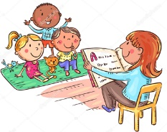

Communication and Language
The development of children’s spoken language underpins all seven areas of learning and development. Children’s back-and-forth interactions from an early age form the foundations for language and cognitive development. The number and quality of the conversations they have with adults and peers throughout the day in a language-rich environment is crucial. By commenting on what children are interested in or doing, and echoing back what they say with new vocabulary added, practitioners will build children's language effectively. Reading frequently to children, and engaging them actively in stories, non-fiction, rhymes and poems, and then providing them with extensive opportunities to use and embed new words in a range of contexts, will give children the opportunity to thrive. Through conversation, story-telling and role play, where children share their ideas with support and modelling from their teacher, and sensitive questioning that invites them to elaborate, children become comfortable using a rich range of vocabulary and language structures.

Autumn | Spring | Summer

Nursery | Throughout the year children will:  - Learn to speak with confidence during circle/carpet times  - Learn to listen and respond appropriately with relevant comments, questions or actions  - Have opportunities to have conversations and develop vocal sound formation in doing this  - To respond to instructions and directions through adult initiated/led and child led activities  - Use appropriate story language to re-enact/re-tell simple and familiar stories  - Learn new vocabulary relating to topics

Reception | Understand how to listen carefully and why listening is important. Understand a question or instruction that has two parts, such as: “Get your coat and wait at the door”  Listen carefully to rhymes and songs, paying attention to how they sound. Learn rhymes, poems and songs.  Develop social phrases. “Good morning, how are you?” Learn new vocabulary and use it throughout the day in different contexts.  Retell a story, once they have developed a deep familiarity with the text; some as exact repetition and some in their own words. Ask questions to find out more and to check they understand what has been said to them. | Listen to and talk about stories to build familiarity and understanding.  Engage in non-fiction books. Listen to and talk about selected non-fiction to develop a deep familiarity with new knowledge and vocabulary.  Describe events in some detail. Connect one idea to another using a range of connectives. Articulate ideas and thoughts in well formed sentences.  Listen to and talk about selected fiction and non-fiction to develop a deep familiarity with new knowledge and vocabulary | Listen attentively and respond to what they hear with relevant questions, comments and actions when being read to and during whole class discussions and small group interactions Make comments about what they have heard and ask questions to clarify their understanding Hold conversation when engaged in back-and forth exchanges with their teacher and peers  Participate in small group, class and one-to one discussions, offering their own ideas, using recently introduced vocabulary. Offer explanations for why things might happen, making use of recently introduced vocabulary from stories, non-fiction, rhymes and poems when appropriate. Express their ideas and feelings about their experiences using full sentences, including use of past, present and future tenses and making use of conjunctions, with modelling and support from their teacher.
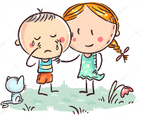
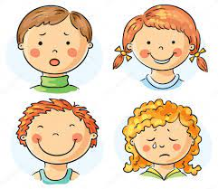
Personal, Social and Emotional Development

Children’s personal, social and emotional development (PSED) is crucial for children to lead healthy and happy lives, and is fundamental to their cognitive development. Underpinning their personal development are the important attachments that shape their social world. Strong, warm and supportive 9 relationships with adults enable children to learn how to understand their own feelings and those of others. Children should be supported to manage emotions, develop a positive sense of self, set themselves simple goals, have confidence in their own abilities, to persist and wait for what they want and direct attention as necessary. Through adult modelling and guidance, they will learn how to look after their bodies, including healthy eating, and manage personal needs independently. Through supported interaction with other children, they learn how to make good friendships, co-operate and resolve conflicts peaceably. These attributes will provide a secure platform from which children can achieve at school and in later life.

Autumn | Spring | Summer

Nursery | Throughout the year children will:  - Make relationships with staff and children in the class  - Understand the boundaries within the classroom and become familiar with our behaviour policy through modelled behaviour  - Get children familiar with the environment Learn routines and follow these  - Children to understand and accept the need of others through the use of group sharing activities and listening games  - Big emphasis on tidy up time use the song to encourage this.  - Children to learn about safety when going out of school  - Children to adapt their behaviour in response to this.  - Children to share feelings about the transition, and to talk about these throughout.

Reception | Talk about their feelings using words like ‘happy’, ‘sad’, ‘angry’ or ‘worried’.  Identify and moderate their own feelings socially and emotionally  Become more outgoing with unfamiliar people and show more confidence in new social situations. Usually dry and clean during the day.  Increasingly follow rules without adult reminders and understand why they are important. Able to dress/undress independently.  Play with one or more other children, extending and elaborating play ideas.  Begin to understand how others may feel. Express their feelings and consider the feelings of others | Talk with others to solve conflicts.  Show resilience and perseverance in the face of challenge.  See themselves as a valuable individual who can manage their own needs. Select and use activities and resources to achieve a goal (with help.  Shows understanding that good practices with regards to exercise, eating, sleeping and hygiene can contribute to good health.  Help to find solutions to conflicts and rivalries.  Build constructive and respectful relationships | Show an understanding of their own feelings and those of others, and begin to regulate their behaviour accordingly. Set and work towards simple goals, being able to wait for what they want and control their immediate impulses when appropriate. Give focused attention to what the teacher says, responding appropriately even when engaged in activity, and show an ability to follow instructions involving several ideas or actions  Be confident to try new activities and show independence, resilience and perseverance in the face of challenge. Explain the reasons for rules, know right from wrong and try to behave accordingly. Manage their own basic hygiene and personal needs, including dressing, going to the toilet and understanding the import  Work and play cooperatively and take turns with others. Form positive attachments to adults and friendships with peers;. Show sensitivity to their own and to others’ needs.

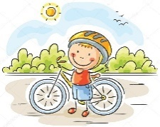
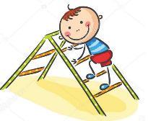
Physical Development

Physical activity is vital in children’s all-round development, enabling them to pursue happy, healthy and active lives7. Gross and fine motor experiences develop incrementally throughout early childhood, starting with sensory explorations and the development of a child’s strength, co-ordination and positional awareness through tummy time, crawling and play movement with both objects and adults. By creating games and providing opportunities for play both indoors and outdoors, adults can support children to develop their core strength, stability, balance, spatial awareness, co-ordination and agility. Gross motor skills provide the foundation for developing healthy bodies and social and emotional well-being. Fine motor control and precision helps with hand-eye co-ordination, which is later linked to early literacy. Repeated and varied opportunities to explore and play with small world activities, puzzles, arts and crafts and the practice of using small tools, with feedback and support from adults, allow children to develop proficiency, control and confidence.

Autumn | Spring | Summer

Nursery | Throughout the year children will:  • Move confidently in a range of different ways on different levels at varying speeds during multi-skills and outdoor provision  • Build up confidence when balancing during gymnastics and outdoor provision  • To be confident when mark making, holding tools appropriately and practicing name writing throughout the whole year  • Become independent with toileting/coats/snack time

Reception | Show a preference for a dominant hand. Use one-handed tools and equipment, ie, making snips in paper with scissors.  Develop their small motor skills so that they can use a range of tools competently, safely and confidently. Suggested tools: pencils for drawing and writing, paintbrushes, scissors, knives, forks and spoons.  Start to eat independently and learning how to use a knife and fork. Develop skills they need to manage school day successfully: lining up and queuing; mealtimes; personal hygiene  Revise and refine fundamental movement skills they have already acquired: rolling; crawling; walking; jumping; running; hopping; skipping and climbing | Use a comfortable grip with good control when holding pens and pencils.  Develop the foundations of a handwriting style which is fast, accurate and efficient.  Know and talk about different factors that support their overall health and wellbeing; regular physical activity; healthy eating; toothbrushing; sensible amounts of screen time; good sleep routine; being safe pedestrian  Develop overall body strength, coordination, balance and agility needed to engage successfully with future physical education sessions and other physical disciplines including dance, gymnastics, sport. | Hold a pencil effectively in preparation for fluent writing – using the tripod grip in almost all cases. Use a range of small tools, including scissors, paint brushes and cutlery. Begin to show accuracy and care when drawing.  Negotiate space and obstacles safely, with consideration for themselves and others. Demonstrate strength, balance and coordination when playing. Move energetically, such as running, jumping, dancing, hopping, skipping and climbing.


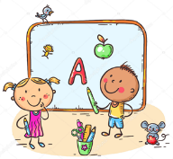
Literacy
It is crucial for children to develop a life-long love of reading. Reading consists of two dimensions: language comprehension and word reading. Language comprehension (necessary for both reading and writing) starts from birth. It only develops when adults talk with children about the world around them and the books (stories and non-fiction) they read with them, and enjoy rhymes, poems and songs together. Skilled word reading, taught later, involves both the speedy working out of the pronunciation of unfamiliar printed words (decoding) and the speedy recognition of familiar printed words. Writing involves transcription (spelling and handwriting) and composition (articulating ideas and structuring them in speech, before writing).

Autumn | Spring | Summer

Nursery | Throughout the year children will:  • Be provided with mark making opportunities throughout all aspects of the indoors and outdoors environment  • Give meaning to marks made/drawings and develop forming recognisable marks  • Show an interest in a range of books, using illustrations and story-telling language to re-tell these stories  • Use daily phase 1 phonics to engage children in letters and sounds, listening games, music and rhyme

Reception | Phase 2  Children can give the sound when shown any Phase 2 letter.  Children can find any Phase 2 letter when given the sound.  Children can sound out and blend vc and cvc words.  Children can read Phase 2 high frequency words and tricky words.  Engage in story times.  Listen carefully to rhymes and songs, paying attention to how they sound.  Learn rhymes, poems and songs.  Shows a preference for a dominant hand.  Hears and says the initial sound in words.  Begins to link sounds to letters, naming and sounding  the letters of the alphabet Uses some clearly identifiable letters to communicate meaning,  Begins to use anticlockwise movement and retrace  vertical lines.  Begins to segment the sounds in simple words and  blend them together.  Develop letter formation.  Writes own name and other things such as labels,  captions | Phase 3  Children can give the sound when shown Phase 2 and Phase 3 graphemes.  Children can find any Phase 2 or Phase 3 grapheme when given the sound.  Children can blend and read words with Phase 2 and Phase 3 graphemes.  Children can segment and make a phonetically plausible attempt at spelling  words with Phase 2 and Phase 3 graphemes.  Children can read Phase 2 and Phase 3 high frequency words and tricky words.  Children can start to spell some high frequency words and tricky words  Re-read these books to build up their confidence in word reading, their fluency and their understanding and enjoyment.  Listen to and talk about stories to build familiarity and understanding. Retell the story, once they have developed a deep familiarity with the text; some as exact repetition and some in their own words  Engage in non-fiction books.  Continues to write labels and captions  Attempts to write short sentences in meaningful contexts.  Begins to break the flow of speech into words.  Begins to use fingers spaces to separate words | Phase 3/ 4  Children can blend and read words with adjacent consonants eg. cr / bl  Children can segment and spell words containing adjacent consonants.  Children can read Phase 2, Phase 3 and Phase 4 high frequency words  and tricky words.  Listen to and talk about stories to build familiarity and understanding. Retell the story, once they have developed a deep familiarity with the text; some as exact repetition and some in their own words.  Listen to and talk about selected non-fiction to develop a deep familiarity with new knowledge and vocabulary.  Writes simple sentences applying their phonics knowledge (phase 2-4)  Uses fingers space independently and more consistently  Continues to develop understanding of capital letters and full stops.  Letter formation and orientation becomes more consistent  Begins to re-read sentences back

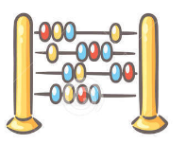
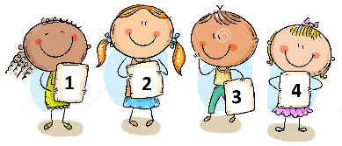
Mathematics
Developing a strong grounding in number is essential so that all children develop the necessary building blocks to excel mathematically. Children should be able to count confidently, develop a deep understanding of the numbers to 10, the relationships between them and the patterns within those numbers. By providing frequent and varied opportunities to build and apply this understanding - such as using manipulatives, including small pebbles and tens frames for organising counting - children will develop a secure base of knowledge and vocabulary from which mastery of mathematics is built. In addition, it is important that the curriculum includes rich opportunities for children to develop their spatial reasoning skills across all areas of mathematics including shape, space and measures. It is important that children develop positive attitudes and interests in mathematics, look for patterns and relationships, spot connections, ‘have a go’, talk to adults and peers about what they notice and not be afraid to make mistakes.

Autumn | Spring | Summer

Nursery | Throughout the year children will:  - recite numbers in order using a range of number songs  - show an interest in numbers in the environment  - show an interest in shapes in the environment and use these during play  - use the language of every day shapes- big/small/tall  - begin to learn names of shapes during focussed activities  - construct using a variety of different shapes, investigating which shapes work and which did not work  - recognise a circle, square, triangle, rectangle, star, heart, diamond confidently and begin to explore patterns  - compare groups and say which has more/less  - begin to recognise numbers 1-5 confidently and begin to match objects to quantity in play

Reception | Number and Place Value- Numbers to 5 Addition and Subtraction- Sorting Number and Place Value- Comparing Groups Addition and Subtraction- Change within 5 Measurement- Time- My Day  Develop fast recognition of up to 3 objects, without having to count them (subitising). Show ‘finger numbers’ up to 5. Link numerals and amounts, eg, showing correct number of objects to match numeral 5.  Recite numbers past 5 and in order to 10. Say one number for each item in order: 1, 2, 3, 4, 5. Know that last number reached when counting a small set of objects tells you how many there are in total (cardinal principle). Count objects, actions and sounds, reciting the numbers in order and matching one number name for each item. Compare quantities using language: ‘more than’, ‘fewer than’. Compare objects: weight, length, size and capacity. Talk about and explore 2D and 3D shapes using information language such as: sides, corners, straight, flat, round. Describe sequence of events (real or fictional) using words such as first, then, next. | Addition and Subtraction- numbers to 5 Number and Place Value- numbers to 10 Addition and Subtraction- Addition to 10 Geometry- Shape and space  Begin to subitise (recognise quantities without counting) up to 5. Solve real world mathematical problems with numbers up to 5. Experiment with their own symbols and marks as well as numerals.  Count verbally beyond 10. Understand the ‘one more/one less than’ relationship between consecutive numbers to 10 Positional language: describe a familiar route, using words such as ‘in front of’ and ‘behind’. Compare numbers using appropriate vocabulary such as ‘more than’ ‘less than’, ‘equal to’. Begin to identify evens and odds to 10. Begin to recall double facts to 10. Begin to share quantities between 2 and 3 people to 10. Talk about patterns in environment and continue copy and create repeating patterns. Select, rotate and manipulate shapes in order to develop spatial reasoning skills. Compose and decompose shapes to show shapes can be made up of smaller shapes. | Geometry- Exploring patterns Addition and Subtraction- Count on and back Number and Place Value- numbers to 20 Multiplication and Division- Numerical Patterns Measurement- measure  Have a deep understanding of number to 10, including the composition of each number; Subitise (recognise quantities without counting) up to 5; - Automatically recall (without reference to rhymes, counting or other aids) number bonds up to 5 (including subtraction facts) and some number bonds to 10, including double facts.  Verbally count beyond 20, recognising the pattern of the counting system; - Compare quantities up to 10 in different contexts, recognising when one quantity is greater than, less than or the same as the other quantity. Explore and represent patterns within numbers up to 10, including evens and odds, double facts and how quantities can be distributed equally.

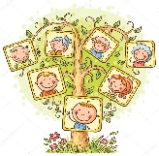
Understanding the World
Understanding the world involves guiding children to make sense of their physical world and their community. The frequency and range of children’s personal experiences increases their knowledge and sense of the world around them – from visiting parks, libraries and museums to meeting important members of society such as police officers, nurses and firefighters. In addition, listening to a broad selection of stories, non-fiction, rhymes and poems will foster their understanding of our culturally, socially, technologically and ecologically diverse world. As well as building important knowledge, this extends their familiarity with words that support understanding across domains. Enriching and widening children’s vocabulary will support later reading comprehension.

Autumn | Spring | Summer

Nursery | Throughout the year children will:  • imitate everyday actions and events from own family and cultural background, e.g. making and drinking tea.  • Beginning to have their own friends.  • Learns that they have similarities and differences that connect them to, and distinguish them from, others.

Reception | Begin to make sense of their own life story and family’s history.  Comment on images of familiar situations in the past.  Explore the natural world around them. Describe what they see, hear and feel whilst outside. Know there are different countries in the world and talk about the differences they have experienced or seen in photos.  Use all their senses in hands on exploration of natural materials. Talk about the differences between materials and changes they notice. Explore and talk about different forces they can feel. | Compare and contrast characters from stories including figures from the past.  Show interest in different occupations. Continue developing positive attitudes about the differences between people. Draw information from a simple map  Understand that some places are special to members of their community. Recognise some similarities and differences between life in this country and life in other countries.  Plant seeds and care for growing plants. Understand the key features of the life cycle of a plant and an animal. Recognise some environments that are different to the one in which they live.  Begin to understand the need to respect and care for the natural environment and all living things. Understand the effects of the changing seasons on the natural world around them. Talk about what they see, using a wide range of vocabulary. | Talk about the lives of the people around them and their roles in society.  Know some similarities and differences between things in the past and now, drawing on their experiences and what has been read in class. Understand the past through settings, characters and events encountered in books read in class and storytelling.  Describe their immediate environment using knowledge from observation, discussion, stories, non-fiction texts and maps. Know some similarities and differences between different religious and cultural communities in this country, drawing on their experiences and what has been read in class. Explain some similarities and differences between life in this country and life in other countries, drawing on knowledge from stories, non-fiction texts and – when appropriate – maps.  Explore the natural world around them, making observations and drawing pictures of animals and plants. Know some similarities and differences between the natural world around them and contrasting environments, drawing on their experiences and what has been read in class. Understand some important processes and changes in the natural world around them, including the seasons and changing states of matter


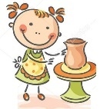
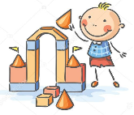
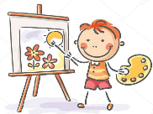

Expressive Arts and Design

The development of children’s artistic and cultural awareness supports their imagination and creativity. It is important that children have regular opportunities to engage with the arts, enabling them to explore and play with a wide range of media and materials. The quality and variety of what children see, hear and participate in is crucial for developing their understanding, self-expression, vocabulary and ability to communicate through the arts. The frequency, repetition and depth of their experiences are fundamental to their progress in interpreting and appreciating what they hear, respond to and observe.

Autumn | Spring | Summer

Nursery | Throughout the year children will:  • Sing a variety of nursery rhymes and become familiar with these  • To move to music and play instruments to a variety of different songs  • Experiments with colours and blocks

Reception | Make imaginative and complex ‘small worlds’ with blocks and construction kits, such as a city with different buildings and a part.  Show different emotions in their drawings. Explore colour and colour mixing.  Take part in simple pretend play, using an object to represent something else even through they are not similar. Use drawing to represent ideas like movement or loud noises  Listen with increased attention to sounds. Respond to what they have heard, expressing their thoughts and feelings. Remember and sing entire songs.  Sing in a group or on their own, increasingly matching the pitch and following the melody. Sing the pitch of a tone sung by another person ‘pitch match’. Sing the melodic shape (moving melody, such as up and down, down and up) of familiar song | Develop own ideas and decide which materials to use to express them. Join different materials and explore different textures. Create closed shapes with continuous lines and begin to use these shapes to represent objects.  Create collaboratively sharing ideas, resources and skills. Draw with increasing complexity and detail, such as representing a face with a circle and including details. Develop storylines in their pretend play  Create their own songs or improvise a song around one they know. Watch and talk about dance and performance art, expressing their feelings and responses.  Play instruments with increasing control to express their feelings and ideas. Listen attentively, move to and talk about music, expressing their feelings and responses. Explore and engage in music making and dance, performing solo or in groups. | Safely use and explore a variety of materials, tools and techniques, experimenting with colour, design, texture, form and function. Share their creations, explaining the process they have used; - Make use of props and materials when role playing characters in narratives and stories.  Invent, adapt and recount narratives and stories with peers and their teacher. Sing a range of well-known nursery rhymes and songs; Perform songs, rhymes, poems and stories with others, and – when appropriate – try to move in time with music.

