
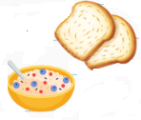
BASC Weekly Menu
Early Birds Breakfast Club
Monday | Tuesday | Wednesday | Thursday | Friday
Cereals  Toast  Fruit | Cereals  Toast  Fruit | Cereals  Toast  Fruit | Cereals  Toast  Fruit | Cereals  Toast  Fruit
*cornflakes, multi-grain cheerios, multi-grain rice crispies weetabix*
** spreads for toast to include jam, marmite**


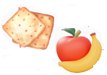
Superstars After School Club
Monday | Tuesday | Wednesday | Thursday | Friday
Crackers  Cheese  Ham/Chicken slices  Carrot/cucumber sticks/cherry tomatoes  Fruit | Pitta  Cheese  Ham/Chicken slices  Carrot/cucumber sticks/cherry tomatoes  Houmous  Fruit | Breadsticks  Cheese  Ham/Chicken slices  Carrot/cucumber sticks/cherry tomatoes  Dip  Fruit | Wraps  Ham/Chicken slices  Carrot/cucumber sticks/cherry tomatoes  Fruit | Pancakes  with spread and fruit
Eating timetable for Superstars Afterschool Club
3:45pm – EYFS/Key Stage 1 children eat (1 adult) and Key Stage 2 have outside playtime (1 adult)
4:10pm - Key Stage 2 children eat (1 adult) and EYFS/Key Stage 1 children have outside play (1 adult)
4:30pm – food is cleared and everyone playing inside, 1 adult to take EYFS/Key Stage 1 children for toilet run in Meldon toilets.
Shopping List – Tesco
Item | Quantity | Cost
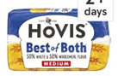  Hovis 50/50 | 4 | £1.25 x 4 = £5
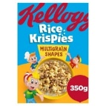  Rice Krispies  Multigrain | 1 | £3.30
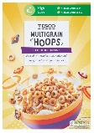  Multi-Grain  Hoops | 1 | £0.85p
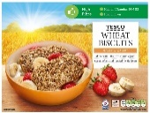  Weetabix | 1 | £2.75
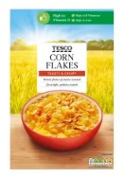  Cornflakes | 1 | 0.70p
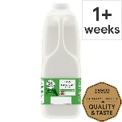  Milk | 3 | £1.45 x 3 = £4.35
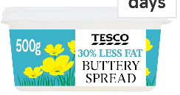  Butter | 2 | £0.95 x 2 = £1.90
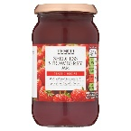  Jam  Seedless  Strawberry | 1 | £0.89
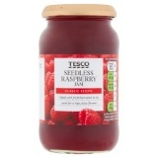  Jam  Seedless  Raspberry | 1 | £0.89
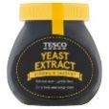  Marmite | 1 | £2.40
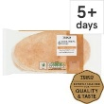  Pitta | 4 | 0.50p x 4 = £2
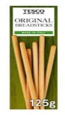  Breadsticks | 4 | 0.55 x 4 - £2.20
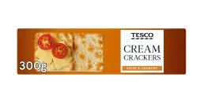  Crackers | 4 | 0.49 x 4 = £1.96
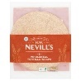  Wraps | 3 | 0.99 x 3 = £2.97
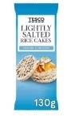  Rice Cakes | 4 | £1.25 x 4 = £5
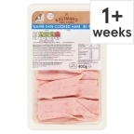  Ham | 2 | £2.09 x 2 = £4.18
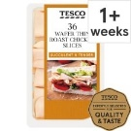  Chicken | 2 | £2.29 x 2 = £4.58
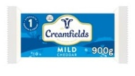  Cheese 900g | 1 | £4.88
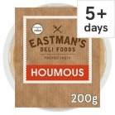  Houmous | 3 | 0.99 x 3 = £2.97
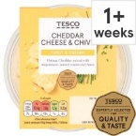  Dip  Cheese &  Chive | 2 | £1.35 x 2 = £2.70
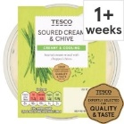  Dip  Sour Cream | 2 | £1.35 x 2 = £2.70
Cucumber  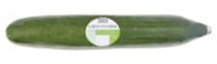 | 5 | 0.99 x 5 = £4.95
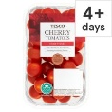  Cherry  Tomatoes | 2 | £1 x 2 = £2
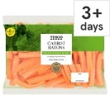  Carrots Sticks | 5 | £1.25 x 5 = £6
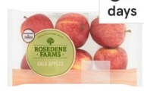  Apples | 4 | £1.49 x 4 = £5.96
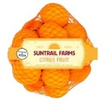  Oranges | 2 | 0.99 x 2 = £1.98
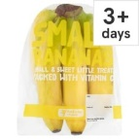  Bananas | 4 | 0.79 x 4 = £3.16
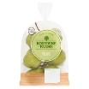  Pears | 2 | 0.99 x 2 = £1.98
TOTAL: £87.60 initial sho

