

St Mary’s Catholic Primary School, Buckfast 2025

Our school community seeks to build on Gospel values to:
- Nurture and respect the talents and abilities that God has given to each unique individual.
- Enable everyone to aspire to and realise their potential through perseverance, resilience and integrity
- To grow in love and to be loved, unconditionally.
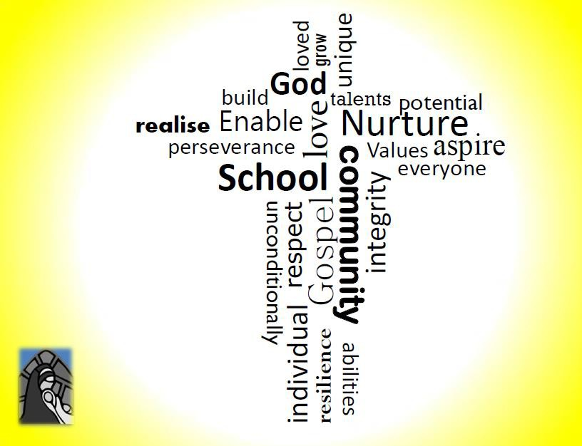

‘Build, nurture, respect, enable, love unconditionally’.

