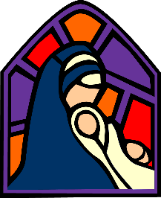
KS 1 History Programme St Marys

