
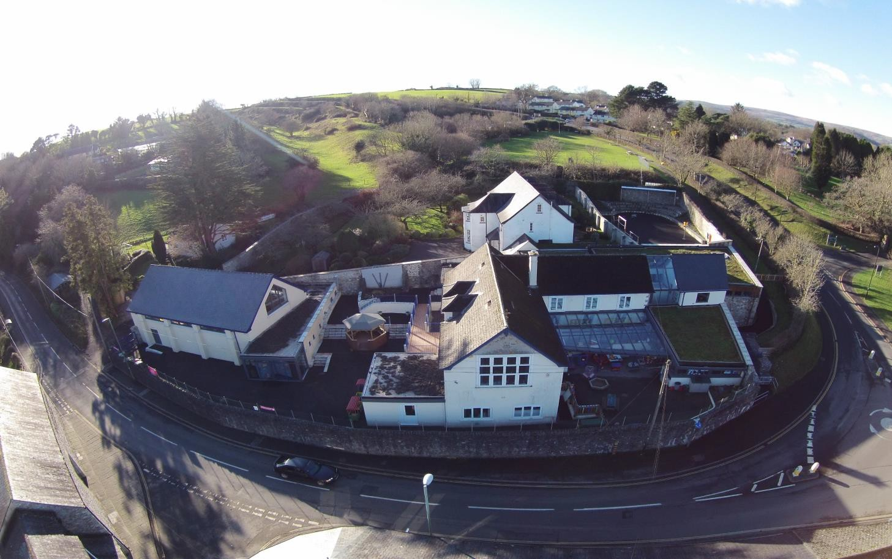

St. Mary’s Catholic Primary School
Headteacher – Mrs Sophie Kerswell
BA (Hons), PGCE
Buckfast Road, Buckfast, South Devon TQ11 0EA Tel: 01364 642389 Fax: 01364 644066

Our School Prospectus

ST MARY’S CATHOLIC PRIMARY SCHOOL

Welcome to St. Mary’s Catholic Primary School. St Mary’s is a small friendly school, committed to the welfare and safeguarding of our pupils.
We encourage all children to be hard-working, polite, cheerful, and ready to help others. Our curriculum is designed to be creative, challenging, and inspiring, enabling our pupils to become independent and resilient life-long learners. Staff work in close partnership with parents/ carers and governors, to create a close and caring community.

These pages provide you with information about our school, its aims, curriculum, and activities. If you would like to find out more about our school, please contact the office to make an appointment to visit and meet our staff and children and have a tour of our beautiful school. We look forward to welcoming you!
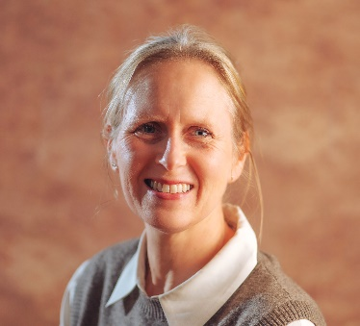

Mrs Sophie Kerswell (Headteacher)

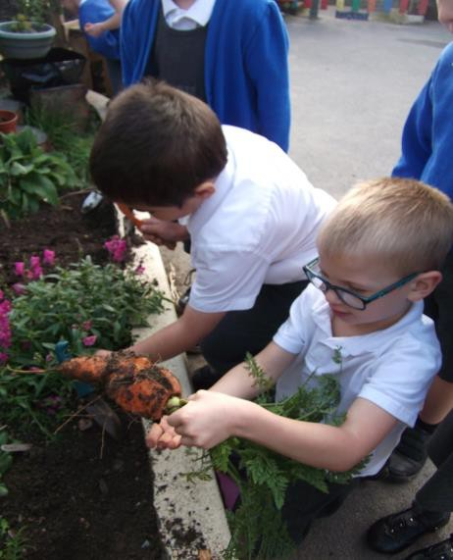
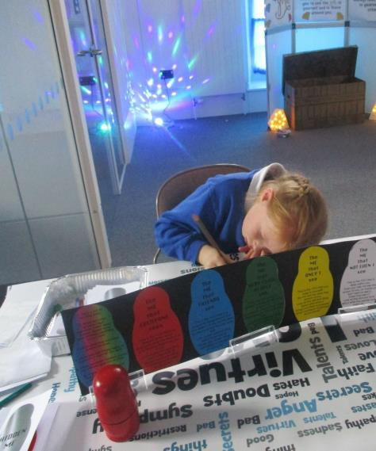
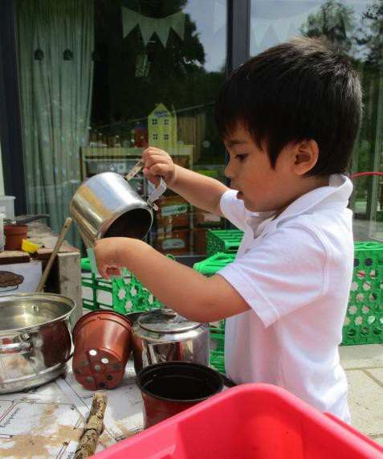

OUR MISSION
The school community at St. Mary’s seeks to provide all children with a stimulating learning environment, permeated by the Gospel values. We hope to recognise, develop, and celebrate all that is unique in everyone and strive to help all attain their full potential, in academic achievement, confidence, co-operation and responsibility.

ST MARY’S MISSION STATEMENT
Our School community seeks to build on Gospel Values to:
- Nurture and respect the talents and abilities that God has given to each unique individual.
- Enable everyone to aspire to and realise their potential through perseverance, resilience, and integrity.
- To grow in love and to be loved, unconditionally.

Some of our school Masses and services are held at Buckfast Abbey, which is within walking distance of our school. We welcome members of our parish to attend school events, such as our Carol Service or our Harvest celebrations. We have strong links with our local parish churches of Buckfastleigh, Ashburton and South Brent. For example, each year, the children decorate the cribs at Christmas in each of the Parish Churches and lead Crib Blessings, which our Parish and school community members attend.
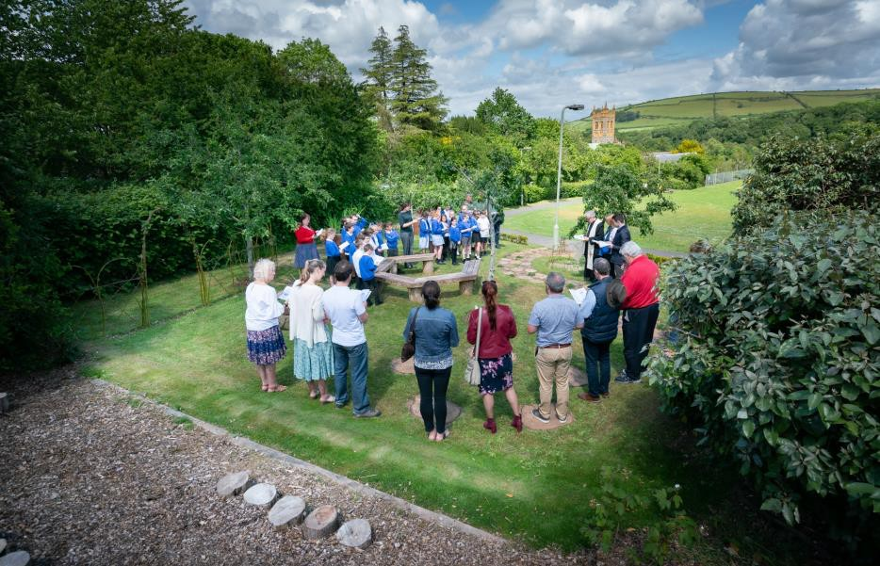

‘Leaders have high ambitions for every pupil, including those with special educational needs and/or disabilities (SEND). There are no barriers to success in the eyes of leaders. This ambitious culture permeates the school.’
(OFSTED 2021)
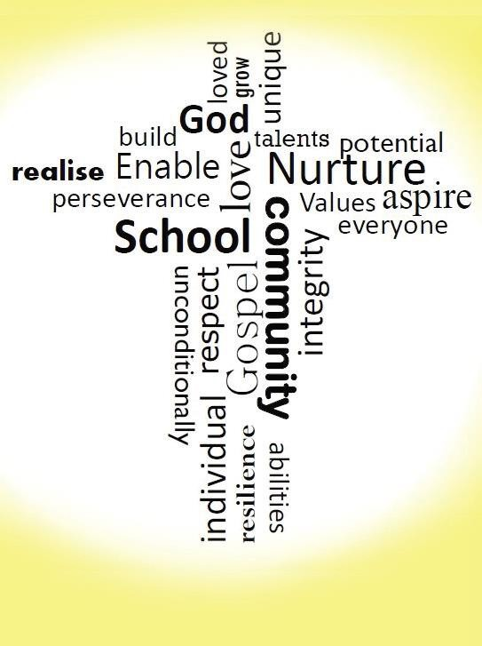
‘The school’s mission statement to ‘Build, Nurture, Enable, Respect and Love
Unconditionally’ underpins every activity within the school and in the wider
community.’ (Section 48 RE Inspection)

OUR SCHOOL

We strive to provide the best learning environment possible for our children. The school places a strong emphasis on outdoor learning for all its pupils,
being perfectly situated in Dartmoor National Park, with the magnificent backdrop of Buckfast Abbey. The children at St Mary’s also benefit from the wealth of resources available at the Buckfast Abbey Education Centre.

We also promote the use of Information Technology, giving pupils the skills and understanding needed to use technology effectively every day and in the world of work ahead. All classrooms have an interactive whiteboard and pupils benefit from a suite of wireless Chromebooks.

A range of extracurricular activities provide
opportunities for our children to pursue their interests
in areas such as sport, music, sport, dance and art.
Our choir are also invited to sing at several community
events during the year. Their Christmas Concert in
Buckfast Abbey is a highlight of our school year!
Our school is proud to collaborate with the Music Department at Buckfast Abbey to offer the Abbey Chorister Programme for our Key Stage 2 children.
This incredible opportunity involves an audition process, and successful children embark on an exceptional musical journey. As Abbey Choristers, they receive individual lessons in voice, piano, and music theory, alongside group singing. They also play an integral role in the music at Buckfast Abbey, gaining unique experiences that nurture their talents and love for music.

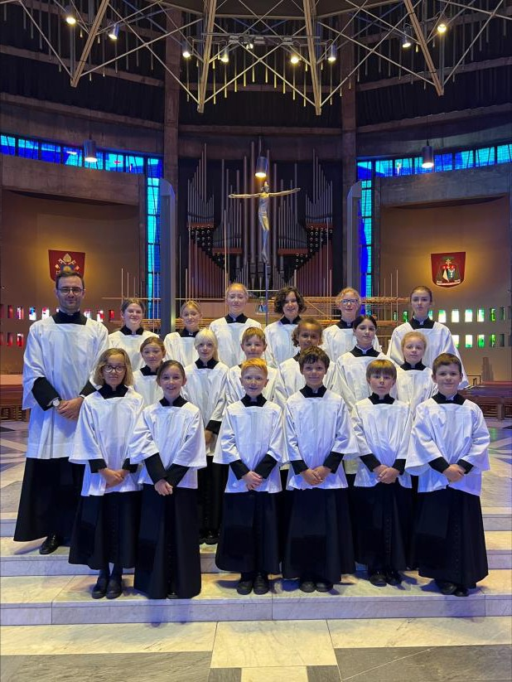

LOCATION AND BUILDING

Geographically and historically, St. Mary's Catholic Primary School occupies a truly unique position. Nestled in the heart of the village of Buckfast, our school is owned by Buckfast Abbey and lies just 500 metres from the Abbey itself, within the breathtaking setting of Dartmoor National Park.

Our school’s original building, dating back to 1893, has undergone extensive renovations over the years. A major milestone was achieved in 2020 with the integration of the original Convent into the school, doubling our capacity. Over the past decade, significant building projects have further enhanced our facilities, including a stunning, light-filled wrap-around extension and a magnificent school hall.

All of this has been made possible thanks to the ongoing support of Buckfast Abbey, who own our school, the Convent, and the beautiful grounds we are privileged to enjoy.

St. Mary’s offers a spacious and inspiring learning environment, complete with a dedicated Early Years Foundation Stage Unit and a variety of outdoor learning spaces. These include an orchard, a large woodland which we have named ‘Bellever’, and a fantastic field, providing endless opportunities for exploration and discovery.
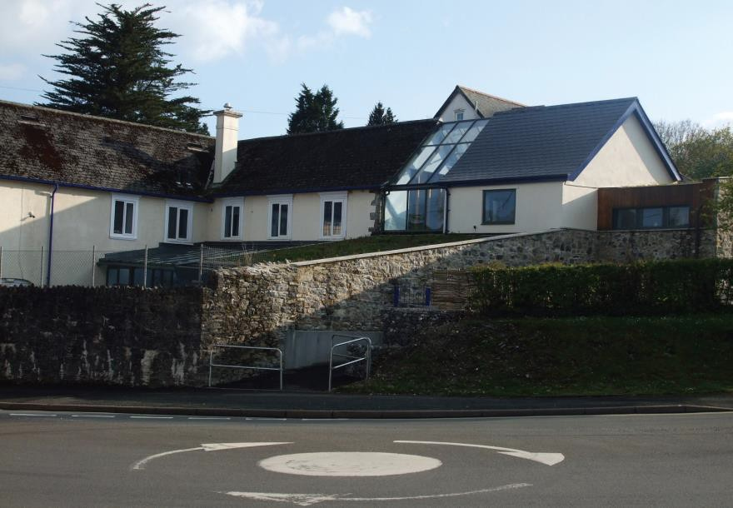

SCHOOL STRUCTURE
Our school has six classes, taking children aged 3 to 11 years old. The six classes are Meldon, Venford, Avon, Roadford, Fernworthy and Burrator, which are named after reservoirs in Dartmoor National Park. Additionally we have Butterbrook - our nurture space- which provides a sensory break out area for some of our children with additional learning needs. We have the benefit of small class sizes and each class is supported by experienced teaching assistants.
ADMISSIONS
Our school has two admissions policies, one for our Early Years Foundation Stage and one for pupils aged 4 years and above, which has been approved by Devon Local Authority. A copy of both policies is available on the school website, or a hard copy can be obtained from the school office upon request.

EARLY YEARS
At St Mary’s Catholic Primary School, we welcome children from 3-11 years old. Our pre-school Early Years children join Meldon Class and are taught by a trained teacher.
We offer a range of sessions to suit you and your child. Foundation Stage sessions run from 8.45-12.00am in the mornings, and 12.00pm until
3.15pm in the afternoons, five days a week. Children attending a session between 12.00pm and 1.00pm can choose to bring a packed lunch, or order a school meal which can be arranged by speaking to the school office and booking through Parent Pay online.

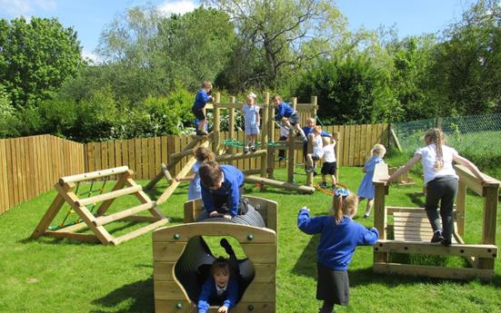
Our approach recognises the very best practice in Early Years education, ensuring a safe, happy and secure environment for children to learn, develop and grow. Children move through the Foundation Stage at their own pace, working within the Early Years Foundation Stage Framework. In line with the rest of the school, pupils experience a topic-themed curriculum, which in the early years focuses on learning through play.

OUR SCHOOL’S CATCHMENT AREA
Our school has a wide catchment area attracting pupils from Totnes, Torbay, Ashburton, South Brent, Ivybridge, Buckfastleigh and other outlying areas. A few our pupils are transported to school by bus or taxi and there are opportunities for subsidised transport (further information can be obtained from the school).

LINKS WITH OTHER EDUCATIONAL SETTINGS
As our pupils may come from other Early Years’ settings, or child minders, we take every opportunity to develop links between the school and these providers. Our Year 6 pupils transfer to various secondary schools every year, so there is a carefully managed programme of transition work for all pupils to enable a successful transfer. Our secondary school links also enable our pupils to take part in a range of curriculum activities. For example, South Dartmoor Community College offers an RE award to pupils, and Ivybridge Community College has worked with St Mary’s to provide gymnastics coaching.

FRIENDS OF ST MARY’S (FOSMS)
The Friends of St. Mary's Catholic Primary School is a group of parents who actively take part in the life of the school. Their aim is to advance the quality of the education at St Mary’s, through fundraising, social events and providing new equipment and enrichment activities for the pupils.


CURRICULUM INFORMATION
Our curriculum is underpinned by a Christian understanding of life and our Mission Statement, which requires the Gospel values to permeate the life of the school.
We aim to:
- Provide a broad, balanced and differentiated curriculum, corresponding to the experience and need of our pupils.
- Encourage our pupils to develop lively and enquiring minds, together with positive attitudes toward learning and a spirit of questioning and exploration.
- Enable pupils to develop language, literacy, mathematic and scientific skills to their full potential.
- Help pupils understand the world in which they live, looking at its context, value, form as well as getting them to appreciate the
interdependence of individuals, groups, and nations.
- Help pupils appreciate human achievement and aspirations in art, music, science, literature, sport, and technology.
- Encourage a healthy response to their physical, spiritual, moral, and creative development so that they experience a high level of self-esteem,

dignity, and purpose.
- Enable pupils to acquire knowledge and skills relevant to, life, in an ever growing and changing world.
- Foster growth in every way to Christian maturity, to value others and be valued as unique individuals in the community.

BRITISH VALUES
St Mary’s Catholic Primary school actively seeks to promote and uphold
British values through its ethos, curriculum, liturgy, and assemblies, aiming to educate and engage with pupils about equality, human rights, and
inclusion in a positive and pro-active way.

EARLY YEARS
When children first join the school, they follow the Early Years Foundation Stage (EYFS) curriculum from 3 years of age. The
curriculum promotes play based learning through exploration. As children progress through Year 1 and achieve all elements of the EYFS, they start to access the National Curriculum. This lays down what should be taught by every school during compulsory schooling from Y1 to Y13. The following
subjects are known as the ‘core’ subjects and will have more time devoted to
them than the others.

ENGLISH
At St. Mary’s Catholic Primary School, we believe that literacy develops the important skills of reading and writing, speaking, and listening, discussion and reflection. In addition to high quality teaching, we aim to foster an interest in this subject area by ensuring that pupils can participate in a range of enrichment activities, such as ‘Poetry Week’ and ‘World Book Day.’

MATHEMATICS
St Mary’s has a clear and comprehensive approach to mathematics, ensuring progression and continuity through the different year groups. We aim to teach our children to think logically, be able to use and apply their knowledge confidently in everyday life and to appreciate and enjoy mathematics.

RELIGIOUS EDUCATION
Religious Education plays a vital role throughout the curriculum as it is
central to the whole ethos of the school. We use the ‘RED or Religious Education Directory’ RE programme of work, to give children the opportunity to explore the Catholic faith, whilst encouraging respect and tolerance of other religions and cultures.We give daily opportunity for the children to take part in prayer and collective worship.

SCIENCE
Our science curriculum aims to give children the experience of a wide range of practical work as well as developing scientific skills and attitudes. As a result of this, the school was awarded the Primary Science Mark. Scientific activities may be taught through individual or group work in order that the children may discover the answers to questions. The school’s grounds are used as outdoor classrooms when an appropriate topic is being studied, and the children are taught how to use scientific equipment and IT safely to
support their learning. Through our science curriculum, we also aim to foster responsible attitudes towards the environment and all living things.

BUILDING LEARNING POWER (BLP)
Throughout all our learning at St Mary’s, pupils are encouraged to
develop and become more aware of their learning and in turn, become more effective learners. Pupils are awarded BLP certificates each week in the Achievement Assembly for developing their learning skills.

FOUNDATION SUBJECTS
The following subjects are known as the ‘foundation’ subjects: Computing, Design Technology (DT), History, Geography, Art & Design, Music, Physical Education (PE), Personal, Social and Health Education (PSHE), Citizenship and Relationships and Sex Education (RSE). These are still taught as discrete disciplines with individual curriculum objectives.

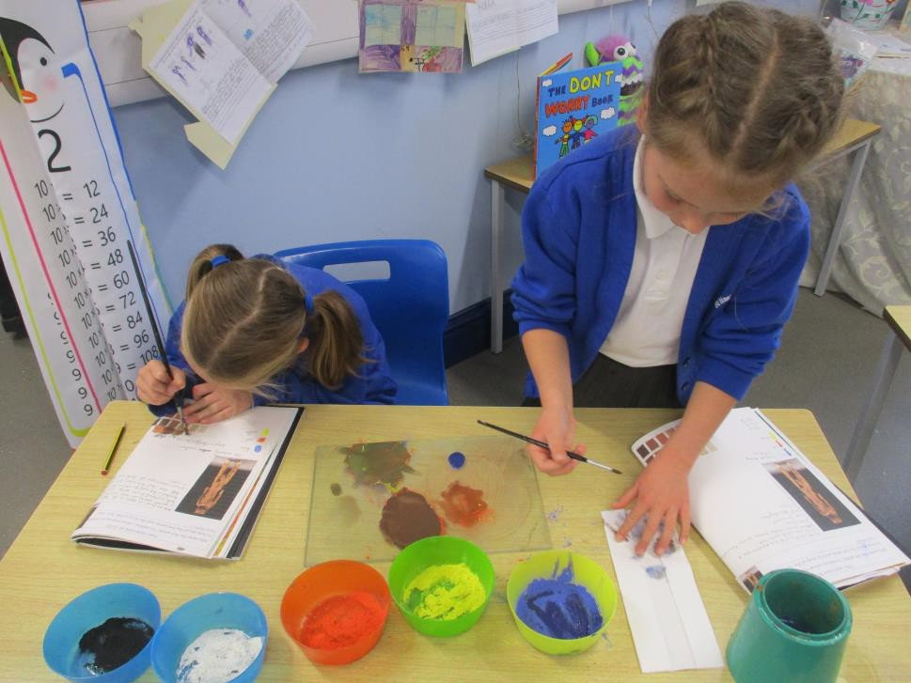
This is in line with evidence from research which shows that children make the best progress when they can make links with their learning. Our curriculum programme also allows us to respond to children’s interests and enable them to pursue themes that interest them. Details of the curriculum being taught each term is sent home to parents/ carers at the beginning of each new term.
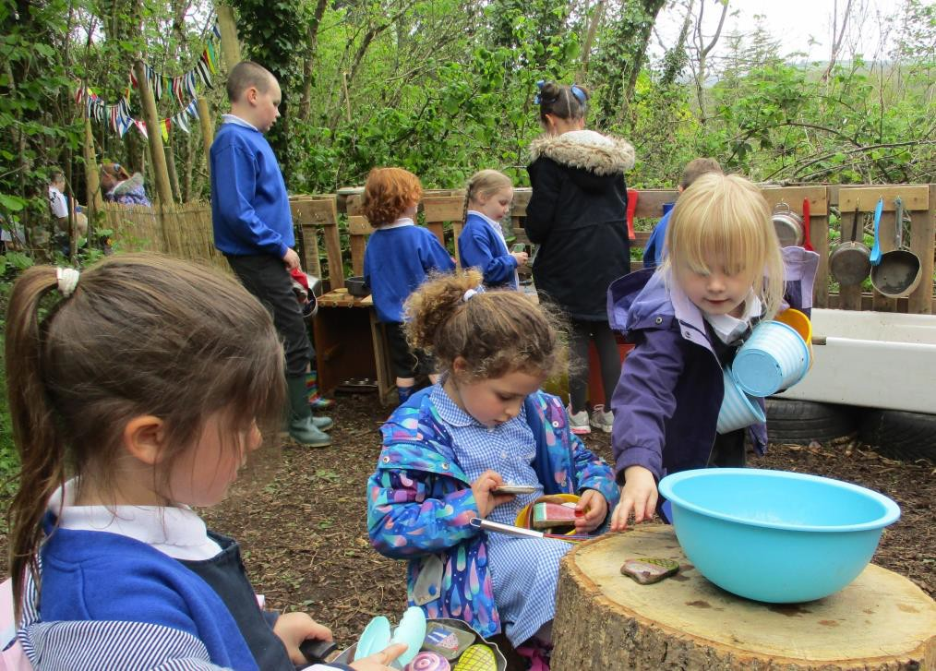

PSHE and RSE
PSHE (Personal, Social and Health Education) is an important element of the curriculum and includes everything schools do to promote pupils' good health and well-being. Relationships and Sex Education (RSE) forms an integral part of this. This programme is a developmental process, which is sensitively delivered through PSHE and science, growing in depth according to each year group. The school uses a programme called ‘Life to the Full’, which has been approved by the Bishops England and Wales. Life to the Full is a Relationships and Health Education (RHE) curriculum programme underpinned by a Christian faith understanding that our deepest identity is as a child of God – created, chosen and loved by God. Each Autumn Term, parents/ carers are invited into school look at the materials for this programme. A link is provided to each family to allow them to access an outline of the content of each lesson in advance. We encourage good communication from home and school. Please contact our PSHE Co-ordinator, Miss Josephine Keir if you wish to know more.
PERSONAL DEVELOPMENT

At St Mary’s, we believe that personal development and well-being are
essential and therefore a priority throughout a child’s life. If a child feels safe and secure at school, everything else that is important in education follows. Our older pupils are encouraged to take an active part in school life at St
Mary’s by becoming Pupil Chaplains, Mini-Vinnies, Buddies, Eco Warriors, and School Councillors. Our Buddies support our younger children with their play. This might include organising games or activities and ensuring younger pupils are happy during break times and lunchtimes. We also have a very active School Council and Eco Committee. The school has been awarded the Green Flag Eco Award and the Live Simply Award, in recognition of the environmental work carried out by pupils. Last year pupils worked on a recycling project in conjunction with Devon Sustainability.

Children at St Mary’s are encouraged to think of others and raise money for charities each term. Our school supports several charities, which are often chosen by our School Council. Year 6 also take part in awards such as the Torbay and Devon Civic Award and Faith in Action Award, which require an element of fund raising and community work to be undertaken by our pupils.

PUNCTUALITY AND ATTENDANCE

Please inform the school at the start of each school day if your child will be absent.
(01364 642389) or admin@st-marysrc.devon.sch.uk.
Regular and punctual attendance is a legal requirement and essential in helping children make the most of the learning opportunities available to them. The school monitors attendance closely with the Educational Welfare Officer and has a number of incentives and rewards for good attendance. For example, individual pupils receive certificates each term for achieving over 97% attendance.
School starts at 8.45am and every pupil is expected to be at school before this time. If your child is just 5 minutes late every day, this equates to missing an hour of school each week, which is over 3 hours a month. Children who arrive late often feel anxious and unsettled about joining the class once the school day has begun, which can affect their concentration for a significant part of the morning.
Learning takes place every day, with teachers planning lessons that build on what the children have already learnt. Missing time from these lessons will leave gaps in knowledge and understanding, which could place children at a disadvantage. Missing a week from school will mean missing about 5 hours of literacy, 5 hours of maths, and 2 hours of science, to name but a few subjects.
Whilst it is accepted that illness is something that cannot be avoided, there are things we can do to limit the amount of school that is missed. If your child needs to attend an appointment during the school day, it would be better for these to be booked during the afternoon. If this is not possible, please try to bring your child back to school after their appointment so that they do not miss out on a whole day’s learning.

SCHOOL STAFF
0ur Senior Leadership Team

Headteacher
Mrs Sophie Kerswell – SENCO, Designated Safeguarding Lead, R.E and Catholic Life Lead, PE and Music Support.

Meldon (Nursery and Reception)
Mrs Kayleigh Teeder – Deputy Designated Safeguarding Lead, KS1 Reading and phonics lead, Science and Early Years Lead.

Mrs Jessica Hutchinson- Deputy Designated Safeguarding Lead, Writing and Spelling Lead, Art, DT, Senior Mental Health Lead.

Class Teachers
Venford (Y1)
Miss Josephine Keir- English and PSHE Lead, and Geography Support.

Avon (Y2)
Mrs Coralie Cherrett- History, PE and Dyslexia Lead. Education Visits Co-ordinator.
Mrs Donna Waiters- Geography Lead.

Roadford (Y3)
Mrs Kerry Manley – Trauma Informed Schools’ Lead Practitioner, Music and Modern Foreign Languages Lead.

Fernworthy (Y4/5)
Mrs Siobhan Deeny- History Lead

Burrator (Y5/6)
Ms Rebecca Blackhall- Maths, Computing, Sustainability, Oracy and Behaviour and Culture Lead.

Butterbrook (SEN Provision)
Mrs Jenna Scholz Higher Level Teaching Assistant– PE Lead

PPA and Teacher Cover – Mrs Rebecca Wirz – Higher Level Teaching Assistant

Burrator (Y5/6)
Miss Josephine Keir- Geography and PSHE/RSE Lead, Fairtrade Lead.

Our Support Staff
Mrs Jo Allen, Mrs Rebecca Bowen, Ms Rubie D’Olley,
Ms Kelly Haines, Ms Naomi Hornsey, Ms Hannah Kerswell, Mrs Kirsty Key,
Mrs Dawn Major, Ms Aimee Owen,Mrs Tracy Owen, Mrs Louise Perrins,
Mrs Bernice Perryman, Ms Molly Palk, Mrs Eleanor Sanderson, Ms Andrea Whitefoot.

Parish Priest-Fr Francis Straw
Senior Administrative Officer-Mrs Laura Vallance
Assistant Administrator- Mrs Ania Walker –
Mealtime Assistant– Mrs Linda Collins
Caretaker- Logan Berry
School Counsellor- Mrs Sarah Knight
School Speech and Language Support – Mrs Ros Sleath

OUR SCHOOL GOVERNORS

Mrs Lesley Clark Chair of Governors and Safeguarding (Foundation Governor)

Mrs Rachel Ellacott (Vice-Chair Foundation Governor)

Doctor Gregory Lippiatt- (Foundation Governor)

Mr Alan Molett (Foundation Governor)

Mrs Samantha Ansell (Parent Governor)

Mr Steve Woods (Health and Safety)

Mrs Kayleigh Teeder (Staff Governor)

Mrs Melanie Harris (Clerk to Governors)

The Head teacher is also a governor.
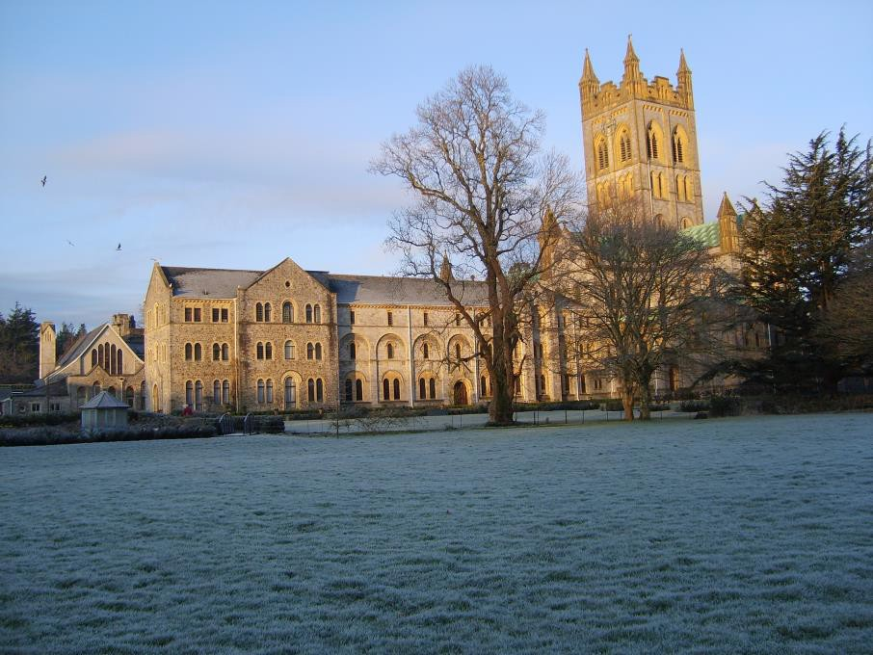

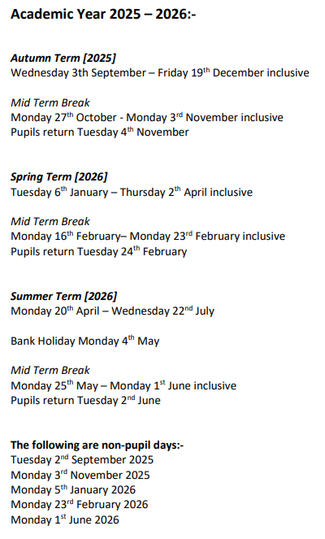
TERM AND HOLIDAY DATES

EMERGENCY CLOSURE
Occasionally, due to severe winter weather the school may have to close. Parents/ carers will be contacted by email. This information will also be posted onto the school website. Local radio stations will also be informed of any school closure.

MORNING ARRIVAL
SCHOOL TIMES
Our school gates open at 8:30 am, and we kindly ask that all children are in class by 8:45 am to start their day on time. You may walk your child down the hill and into the playground- where a member of staff will be there to greet them.

Morning session
8.45am-12.15pm
Morning break 10.30-10.45am
Lunchtime 12.15pm-1.15pm

Afternoon session
1.15pm-3.30pm

Our school day finishes at:
- 3:15 pm for Early Years and Key Stage 1 children
- 3:30 pm for Key Stage 2 children
To help ease car park congestion and make pick-up smoother for everyone, if you have children in both Key Stages, we’d really appreciate it if you could collect all your children at 3:30 pm

END OF DAY ARRANGEMENTS- Where to Collect Your Children:
- For children in Key Stage 1 (Venford Y1, and Avon Y2), please walk down the hill to the side door of Venford Classroom
- For children in Years 3, 4, 5, and 6, Roadford, Fernworthy and Burrator (pick-up will be from the lower playground opposite the main office.

If you prefer to collect your Key Stage 1 child at 3:15 pm and wait for your Key Stage 2 child, you’re welcome to wait in the playground or the enclosed porch area. This helps us keep classrooms and offices running smoothly and avoids congestion.

Please let the office know if there are changes to a pupil’s normal collection arrangements.

If your child is still in school by 3:45pm, then they will be placed in our ‘Superstars After School Club’ and charged accordingly. If by 4:45pm, we have not been able to contact parents/ carers, we will inform Devon Social Services through the MASH (Multi Agency Safeguarding Hub) team.
LUNCH AND BREAK TIMES

At break times, children in our Foundation Stage Unit and Key Stage 1 (Nursery, Reception, Year 1 and Year 2 – Meldon, Venford and Avon) are offered a piece of fruit as a snack each day. If your child prefers to bring their own snack, please ensure it is a healthy option, such as fruit or a cereal bar. Fizzy drinks, sweets, crisps, and chocolate bars are not permitted during break times. Drinking water is readily available for all children throughout the school day, with cups and fresh water in each classroom.

School Meals
- Free Meals: School meals are provided free of charge for all pupils in Reception and Key Stage 1.
- Paid Meals: For children in other year groups, meals can be purchased via our online portal, Parent Pay. All meals, whether free or paid, must be booked online. If you need assistance, please contact Mrs. Ania Walker in the school office for guidance.

Lunch Menus:
Menus are online on Parent Pay.

Free School Meals Entitlement:
Families receiving certain income-based benefits may qualify for free school meals. For more information and to apply, visit Devon County’s free school meals page. https://www.devon.gov.uk/support-schools-settings/administration-and-finance/administration/free-school-meals/
Even if your child does not wish to have a school meal, applying helps the school receive additional funding to support all our pupils.

Packed Lunches
Children are welcome to bring a packed lunch if they prefer. Please ensure packed lunches do not include fizzy drinks, sweets, hot soups, or hot drinks. The school regularly shares healthy packed lunch ideas through newsletters and on our website.

SCHOOL UNIFORM

All children are expected to wear the school uniform which is:
- a royal blue sweatshirt or cardigan with school logo
- dark grey trousers or dark grey skirt
- white polo shirt or white shirt
- grey or white socks
- grey tights
- black shoes or ankle boots.

In the summer, pupils may wear:
- a blue and white checked dress or;
- grey shorts and white polo shirt/shirt
- black closed toe sandals

Watches and small stud earrings are permitted, but for safety reasons jewellery must be removed (or earrings taped) for P.E. lessons. Hair accessories must be discrete, and brown, black or school colours.

For P.E lessons children wear a pale blue t-shirt with our school logo, navy, or black shorts and plimsolls or trainers. In the winter months, jogging bottoms or leggings may be worn for outside lessons instead of shorts. Pupils are asked to come into school in PE kits on the days that they currently have PE.

Uniform items specific to St. Mary’s Catholic Primary School can ordered online through Brigade Clothing
http://www.brigade.uk.com/direct/index.php

Other non-specific items are readily available from various retailers.

We can offer good quality secondhand clothing and we are always happy to receive items to contribute to this.

HOME LEARNING
GENERAL INFORMATION
All classes are set home learning throughout the school in accordance with government guidelines and the school’s home learning policy, which is available on the school website, or from the school office.

RELIGIOUS WORSHIP
As St. Mary’s is a Catholic School, faith permeates all levels of school life. Mass is celebrated in the school hall or in Buckfast Abbey and parents/ carers are usually invited to attend.

HEALTH AND PASTORAL CARE
All members of staff hold Emergency First Aid qualifications and six members of staff have been fully trained in Paediatric First Aid. We also take the emotional well-being of our pupils very seriously and currently employ a school councillor/ play therapist to help support social and emotional development.

SAFEGUARDING CHILDREN
At St Mary’s the health, safety and well-being of every child is taken very seriously. To promote a safe environment for pupils, our selection and recruitment policy makes checks on all staff and regular volunteers’ suitability, including Disclosure and Barring Service checks, in accordance with current legislation.

MEDICINES
We can administer medicine, both prescribed and non-prescribed. Please fill in a consent form from the school office (also available on our website).

INSPECTION
The Office for Standards in Education (OFSTED) inspects all schools about every four years. We were last inspected in November 2021 and received a very positive report; we were judged to be a ‘good’ school. You can view or download our inspection reports from the Ofsted website: www.ofsted.gov.uk.

EQUALITY POLICY
The primary aim of St Mary’s Catholic Primary School is to enable all pupils to take part as fully as possible in every part of school life. The school will take steps to advance equality of opportunity, foster good relations and eliminate discrimination or harassment across all the protected characteristics within the school community. A copy of the Equality Objectives can be accessed via the school website or obtained from the school office.

SPECIAL EDUCATIONAL NEEDS AND DISABILITIES (SEND)
St. Mary’s is a truly inclusive school and recognises the unique worth of every
child. It adheres to the SEN Code of Practice (2014) and reflects the ‘Every Child Matters’ agenda to ensure that every child is happy at school and that their potential is fulfilled.

HIGH ACHIEVING PUPILS
St Mary’s encourages and celebrates the talents of all its pupils. Our weekly Achievement Assemblies enable pupils to share their successes outside school, e.g., in sports and music. The school also identifies pupils with high achievement in a particular curriculum area and looks for enrichment opportunities for these pupils both in and out of school.

BEHAVIOUR
Our school is a Trauma-Informed School, and our approaches are grounded in fostering positive mental health and wellbeing through strong, supportive relationships. We use the PACE (Playful, Accepting, Curious, and Empathetic) approach developed by Dan Hughes to support children experiencing intense emotions or "big feelings."

A key focus is ensuring psychological safety, which creates the optimal environment for learning. To encourage positive behaviour, we implement a system of rewards. Details of these rewards are displayed throughout the school and outlined in our behaviour policy, available on our school website or from the school office.

Our relational approach to behaviour management prioritises connection as the foundation of everything we do. By building meaningful connections, we teach our children the importance of our three core rules: Ready, Respect, and Safe. This approach helps children internalise these values and apply them to their lived experiences.

We understand that behaviour is a form of communication. When children display behaviours that are not acceptable, we respond with the PACE approach, acknowledging and accepting the feelings behind the behaviour while not accepting the behaviour itself. Once the child is ready, we engage in restorative conversations to teach alternative, healthier ways to express emotions. These conversations are a cornerstone of our behaviour support strategy.

In some cases, "logical consequences" may also be applied, tailored to the specific behaviour and context. For children who struggle consistently with their behaviour, we create personalised Relational Support Plans. These working documents are shared with all adults involved in supporting the child, ensuring a consistent and effective approach.

ASSESSMENT
Teacher assessment in the core subjects of Mathematics, English, RE and Science takes place on a continuous basis, to inform the planning of work for individuals and small groups of children. Foundation subjects are also assessed each year and reported in the child’s End of Year School Report.

Each term, we formally assess reading and maths and this is reported on to our data system – INSIGHT.

Statutory assessments takes place in:
Reception – Baseline Assessment
Year 1 - Phonics screening
Year 4 - Multiplication Check
Year 6 – SATs (Statutory Assessment Tests)

VISITS
The school takes every opportunity to offer a range of enrichment
activities to all pupils during the year. Visits and themed days are offered each year across the school, to enhance a range of different curriculum areas.
Pupils in Year 5 and 6 take part in an ‘Activities week’ every other year, involving a residential stay, usually based at Grangehurst Residential Centre, Buckfast, in Dartmoor National Park.

SCHOOL PHOTOGRAPHS
The photographer visits our school twice a year; in the Autumn term to take individual or family group photographs and in the Summer term to take class photographs. There is no obligation to purchase photographs, but if you wish to do so, these can be ordered and paid for online. There are also occasions when children may be photographed for use on the school website or for school publicity purposes. Each parent is consulted at the start of the year about whether they are happy for this to happen.

COMPLAINTS
Whilst we hope that you will always be happy at our school, there may be occasions where you wish to discuss a matter further. We are always happy to listen to parents’ comments as they may help us to develop a better understanding of our school community.

In the first instance, we would hope that all complaints could be dealt with by talking to the Class Teacher or a member of the Senior Leadership Team. Then if a parent or carer feels that the issue is still not resolved, the staff member will report the issue to the Head Teacher. If after this, a parent feels they have not had their issue resolved, then the school complaints procedure should be followed. A copy of this is available from the school office or on the school website.
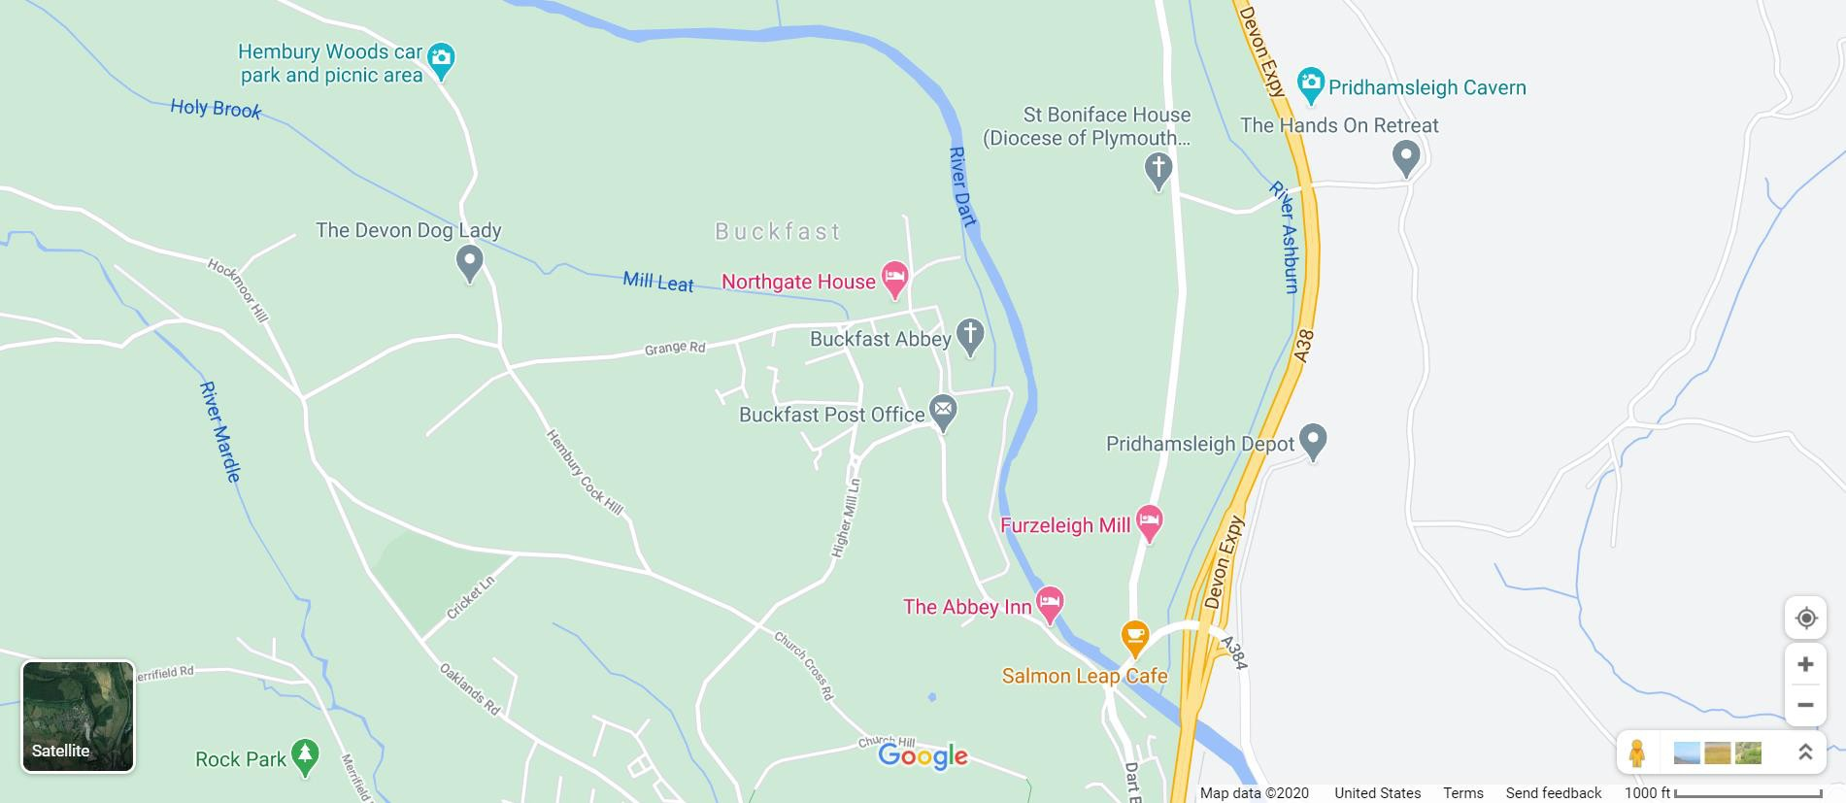
HOW TO FIND US

