Plymouth CAST Model Special Educational Needs and Disability Policy

Last Update: June 2023 Previous Update: June 2021

Document Control
Changes History
Schools are required to ensure that any new statutory guidance related to SEND , Exclusions and Safeguarding are implemented as required at the time of publication. Changes to this policy will be formally adopted as soon as practically possible.

Version | Date | Amended by | Recipients | Purpose
2.0 | June 2021 | Kevin Butlin - Director of Education and Standards | All Plymouth CAST staff | Statutory Policy Review
3.0 | June 2023 | Kevin Butlin - Director of Education and Standards | All Plymouth CAST Staff | Statutory Policy Review
Approvals
This policy requires the following approvals:

Board | Chair | CEO | Date Approved | Version | Date for Review
 |  |  |  | 2.0 | July 2021
 |  |  |  | 3.0 | July 2023
X |  |  |  | 4.0 | July 2025

National/Local Policy
- This policy must be localised by schools
- This policy must not be changed, it is a National Policy (only change logo, contact details and yellow highlighted sections)
Position with the Unions

Does the policy require consultation with the National Unions under our recognition agreement? ☐ Yes ☐ No If yes, the policy status is: ☐ Consulted and Approved ☐ Consulted and Not Approved ☐ Awaiting Consultation
Distribution
This document has been distributed to:

Position | Date | Version
All Plymouth CAST HTs |  | 3.0
All Plymouth CAST SENCOs |  | 3.0
Plymouth CAST Directors and SEL |  | 3.0

Contents

The Mission of the Catholic Church and Safeguarding Page 4
Purpose Page 4

Terminology Page 5
- Introduction Page 5

- Vision Page 6
- Principles Page 6

- The Plymouth CAST SEND Approach and strategy Page 6
- Definition of SEND Page 6

- Working across Education, Health and Care Page 7
- Accurate and early identification Page 7

- Early Years and Nursery Provision Page 7
- Primary, Secondary and post-16 provision Page 8

- Securing excellent outcomes for pupils who have SEND Page 9
- Supporting out schools Page 9

- The role of the SENCO Page 10
- Remote Learning Page 10

- Careers Education Page 11
- Extra-Curricular Activities Page 11

- Behaviour Policy and Exclusions Page 11
Key Contacts for SEND at the School and the Trust

Key Personnel
Mrs Sophie Kerswell
Contact details: email: admin@st-marysrc.devon.sch.uk Telephone: 01364 642389

Mrs Samantha Ansell
Contact details: email: admin@st-marysrc.devon.sch.uk Telephone: 01364 642389

Mrs Sophie Kerswell
Contact details: email: admin@st-marysrc.devon.sch.uk Telephone: 01364 642389

Mrs Lesley Clark

Contact details: email: lclark@buckfast.org.uk Telephone: 01364 642389

Plymouth CAST lead for SEND: Kevin Butlin (Director of Education and Standards)
Contact details: email: kevin.butlin@plymouthcast.org.uk Telephone: 07513 136390

Plymouth CAST Model SEND Policy 2023

Governors’ Committee Responsible for local dissemination and monitoring:
Governor Lead:
Date adopted by local governing body: September 2024

The Mission of the Catholic Church and Safeguarding
“The Catholic Church and its individual members will undertake appropriate steps to maintain a safe environment for all and to practise fully and positively Christ's Ministry towards children, young people and adults at risk and to respond sensitively and compassionately to their needs in order to help keep them safe from harm. This is demonstrated by the provision of carefully planned activities for children, young people and adults, caring for those hurt by abuse and ministering to and robustly managing those who have caused harm.” [Source: National Catholic Safeguarding Commission - Policy Statement February 2016

Purpose
The purpose of this policy is to provide staff, volunteers and governors with the framework by which pupils with SEND should be included and educated in our schools, and to inform parents and guardians how we will identify need, establish effective provision and improve outcomes for children and young people who have SEND while they are in our schools.

Terminology
SEND is an acronym for Special Educational Needs and/or Disabilities.

Child includes everyone under the age of 18.
Parents refers to birth parents and other adults who are in a parenting role, for example step-parents, foster carers and adoptive parents.

SENCO is an acronym for the Special Educational Needs Coordinator who is the leader within a school responsible for SEND provision. By law, the SENCO must be a qualified teacher.
Education, Health and Care plan (EHC plan) details the education, health and social care support that is to be provided to a child or young person who has SEN or a disability and has been awarded a ‘statutory assessment’. It is drawn up by the local authority after an EHC needs assessment of the child or young person has determined that an EHC plan is necessary, and after consultation with relevant partner agencies.
Early identification of SEND is a key principle of the SEND Code of Practice 2014. Schools should have systems and processes in place, in collaboration with their local area, to ensure that pupils who have SEND are identified as quickly as possible.
Special educational provision is provision that is different from or additional to that normally available to pupils or students of the same age, which is designed to help children and young people with SEN or disabilities to access the National Curriculum at school or to study at college.

Inclusion is the principle that children with Special Educational Needs and/or a Disability have the right to be educated alongside other children from their community.
Annual review is the review of an EHC plan which the local authority must make as a minimum every 12 months.

Early years provider is a provider of early education places for children under five years of age. This can include state-funded and private nurseries as well as child minders.
Local Offer. Local authorities in England are required to set out in their Local Offer information about provision they expect to be available across education, health and social care for children and young people in their area who have SEN or are disabled, including those who do not have Education, Health and Care
(EHC) plans. Local authorities must consult locally on what provision the Local Offer should contain.
Local Area is the term used for all the services that make up the local offer within a local authority. Therefore, the local area includes schools, health and care providers, charities and any service that works for the benefit of pupils who have SEND and their families.

Local Authority is a local government body that is officially responsible for all the public services and facilities in a particular area. For example, Devon County Council or Plymouth City Council.

Introduction
This policy has been written to meet the expectations within the law and statutory guidance from September 2014 and to reflect the Special educational needs and disability code of practice: 0-25 years (July 2014). It sets our vision and principles for children and young people who have SEND.

The policy sets out our expectations for all our schools and those regarding joint working with parents, local authorities and our health and social care partners. These expectations will ensure we are compliant with both the letter and spirit of the SEND reforms and serve to improve outcomes for young people who have special educational needs and/or disabilities.

Vision
Our vision for children and young people with special educational needs and disabilities is the same as for all children in our academies. We aim to provide outstanding education to all children and young people. We are fully inclusive in our provision in terms of social background, ability, ethnicity, religion, gender, or sexuality. We strive to ensure access for all to educational excellence in preparing young people for their futures, seeking to continually improve levels of attainment and progress for all, and secure the highest levels of achievement appropriate to the individual learner.

Principles
  - We shall ensure that all our schools have regard to the views, wishes and feelings of the child or young person who has SEND and the child’s parents or carers.
  - We shall work closely with and support the local authorities in which our schools are located to assist them in fulfilling their obligations under Part 3 of the Children and families Act 2014 and its associated guidance.
  - We shall ensure that each of our schools has procedures in place which allow them to fulfil both their statutory duties and support the wider vision and ethos contained in the SEND Code of Practice (July 2014).
All schools will operate within the law, including:

  - part 3 of the Children and Families Act 2014
  - the Special educational Needs and Disability Regulations 2014
  - the Special Educational Needs (Personal Budgets) Regulations 2014
  - the Equality Act 2010.

All schools will follow the statutory guidance in full, including that within:

  - the special educational needs and disability code of practice: 0 to 25 years
  - the transition to a new 0-25 special educational needs and disability system.

The Plymouth CAST SEND Approach and strategy
Plymouth CAST will promote an approach in all our schools of improving outcomes for children and young people who have SEND. Our approach is based on four principles that are the key priorities within the trust’s SEND strategy. Our priorities are:
  - making the best use of resources to close gaps in provision
  - improving outcomes by strengthening inclusion
  - implementing effective policy, systems and processes relating to the trust and school SEND offers
  - building capacity in SEND leadership through effective networking

Definition of SEND
  - A child or young person has special educational needs if they have a learning difficulty or disability which calls for special educational provision to be made for him or her.
  - A child of compulsory school age or a young person has a learning difficulty or disability if he or she:
    - has a significantly greater difficulty in learning than the majority of others of the same age, or
    - has a disability which prevents or hinders him or her from making use of facilities of a kind generally provided for others of the same age in mainstream schools or mainstream post- 16 institutions.
For children aged two or more, special educational provision is educational or training provision that is additional to or different from that made generally for other children or young people of the same age by mainstream schools, maintained nursery schools, mainstream post-16 institutions or by relevant early years providers. For a child under two years of age, special educational provision means educational provision of any kind.

Working Across Education, Health and Care
We will work jointly with education, health and care bodies, including the local authorities where our schools are located, and professionals to secure effective outcomes for young people in our schools.
Each CAST school will cooperate with the relevant Local Authority in developing and reviewing its Local Offer.

Each CAST school will make reasonable adjustments for disabled young people (including the provision of auxiliary aids and services) and will make arrangements to support those with medical conditions.
We shall work with our schools, local and national providers to secure the services needed to improve outcomes for children and young people who have SEND. These services could include speech and language therapy, physiotherapy, occupational therapy, education psychology, mental health services, other health and social care professionals.

Accurate and timely identification
Our Early Years and Nursery providers will ensure that screening procedures are in place to identify children with SEND early and to ensure that they receive the support they need.
All CAST schools will undertake an early assessment when pupils enter their schools, reviewing a young person’s skills and attainment, while considering any information provided by previous settings.
As part of the screening process, school leaders will consider any evidence that the child or young person may have a disability under the Equality Act 2010 and make reasonable adjustments for them. The details of how the school plans to meet the needs of any child or young person with a disability should be shared immediately with the CAST central team via the school’s Education and Standards Manager (ESM).
The senior executive leader for SEND in the trust will support school leaders and SENCOs to secure accurate and early identification of needs. Pupils’ needs will be categorised into the four main areas of need, as detailed in the Code of Practice. Once categorised, pupils with identified SEND should be recorded on the school’s SEND register.
The ‘SEND Code of Practice’ (January, 2015) identifies four broad categories. These are:

- Communication and interaction, including Speech and Language difficulties and Autistic Spectrum Disorders
- Cognition and learning, including specific learning difficulties e.g. dyslexia
- Social, emotional and mental health, including anxiety, depression and ADHD
- Sensory or Physical, including hearing, visual or physical disabilities

Plymouth CAST leaders will ensure that systems and processes associated with the effective identification of learners with SEND are consistently applied according to local area criteria within each school in the trust. School leaders will utilise this to ensure equitable provision across CAST schools.

Early Years and Nursery Provision
As an inclusive Trust, our aim is for children with SEND to be educated alongside children who do not have SEND.

Our Early Years or Nursery providers will designate a qualified teacher to be responsible for coordinating SEND provision (the SENCO) who will either be an experienced SENCO or have or be working towards the prescribed qualification.
We shall inform parents when we are considering making special provision for a child and shall then work in partnership with them to co-produce the support needed and secure best outcomes, taking full account of their views and wishes.
We shall adopt a graduated approach with four stages of action: assess, plan, do and review as set out in the SEND Code of Practice 5.36-5.46.
Each Nursery or early years provider shall prepare an annual report on the implementation of our SEND policy including:
- arrangements for the admission of disabled children
- steps being taken to prevent disabled children from being treated less favourably than others
- the accessibility plan and how it will be improved over time
- how the setting organises effective coproduction of provision with children and their parents.

Primary, Secondary and post-16 provision
Schools will have measures in place to accurately identify children and young people with SEND and will place such pupils on ‘SEN Support’ in consultation with their parents or carers. When necessary, school leaders will make statutory assessment applications to their local authorities whenever they believe a child requires an education, health and care plan. School leaders must be aware of the criteria for assessment agreed by their local authority. All pupils identified as ‘SEN Support’, going through a statutory assessment and those with an education, health and care plan will be recorded on a SEND register. The register will be regularly reviewed by leaders, as well as annually alongside the ESM linked to the school.
CAST schools will do everything they can to meet the needs of children and young people who have SEND, including delivering the education elements of an Education, Health and Care Plan. When appropriate, schools will also support young people to achieve the outcomes set within the health and care elements of their plans. School leaders will regularly assess pupils’ progress towards achieving the outcomes set in their EHC plans and inform parents of the progress being made.
School leaders will ensure that children and young people who have SEND engage in the activities of the school alongside those who do not have SEND, unless a particular provision agreed with the parents or carers, the young person and the school’s ESM is in place.
CAST Schools will designate a qualified teacher to be responsible for coordinating the SEND provision (the SENCO), who will have or be working towards attaining the National Award in Special Educational Needs Coordination.
School leaders will inform parents or carers when they are planning special educational provision for their child and shall then work in partnership with them to co-produce the support needed to secure best outcomes, taking full account of their views and wishes. Whenever possible, school leaders will also co-produce the support needed alongside the child who needs the support.
CAST Schools will prepare a SEND Information Report in accordance with paragraphs 6.79 onwards of the SEN Code of Practice and publish it on their website. The SEN Information Report will set out details regarding the implementation of the Plymouth CAST SEND Policy.
CAST schools will designate a member of the local governing board or interim academy board to take oversight of the school’s arrangements for SEND and their implementation of the trust’s SEND policy.
School leaders will ensure that all staff accept that SEND is their responsibility and, in particular, that class and subject teachers take full responsibility for the progress of children with SEND whom they teach.
School leaders will ensure that the quality of teaching for pupils with SEND and the progress made by those pupils are a core part of performance management arrangements.
Class and subject teachers, supported by the SENCO and Senior Leadership Team, will make regular assessments of the progress and attainment for all pupils who have SEND and identify appropriate actions, particularly for those making less than expected progress, given their age and prior attainment.
Schools will ensure that a Graduated Approach as set out in paragraphs 6.44-6.56 of the Code of Practice is in place for all young people on ‘SEN Support’. Schools will make use of the CAST SEND Pathway and Identification Checklist to support the identification and provision for children with SEND.
For all young people receiving SEN Support, School leaders will make arrangements for a qualified teacher to meet the parents (or carers) at least three times a year to review progress and discuss support.

Securing excellent outcomes for pupils who have SEND
Pupils with SEND might face significantly greater challenges in learning than the majority of their peers, or have a disability which hinders their access to the teaching and facilities typically found in mainstream educational settings. There is a very large attainment gap between pupils with SEND and their peers.
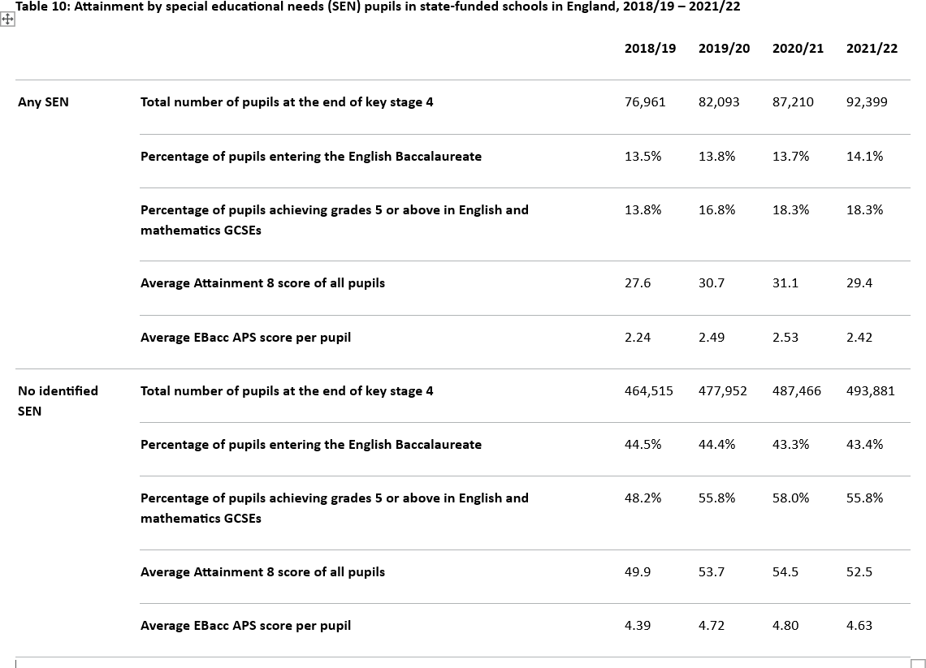

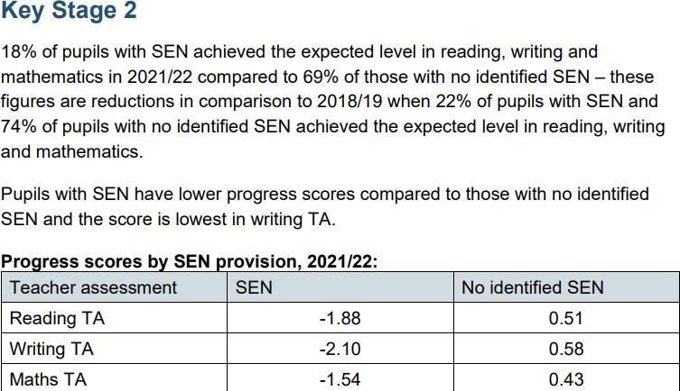

At Plymouth CAST, the primary focus when looking to secure positive outcomes for pupils who have SEND is to help them narrow their attainment gap with other pupils nationally. Nevertheless, the trust recognises that children and young people who have SEND need to secure positive outcomes in all areas of learning, in their own physical and mental health and socially. Therefore, as well as measuring the academic attainment and progress of pupils who have SEND, CAST schools are likely to have specific ways of measuring pupils progress across other measures, including against the targets in their education, health and care plans or individual education plans, where relevant, or by measuring improvements to pupils’ behaviour over time.

Supporting our Schools
We shall offer a SEND service to all our schools to advise and support them in the implementation of the Plymouth CAST SEND Policy and in the improvement of outcomes for all children and young people who have SEND. The service offer will include:
- SEND audits and reviews of provision
- Pre-Ofsted preparation
- Legal advice
- Support for identification and intervention
- Staff training and conferences
- SENCO cluster meetings to inform and share best practice
- Specialist assessments
- Fostering of partnership working and the brokering of support services
- Specific support for schools with SENCOs that are new to post

Role of the Special Educational Needs Co-ordinator (SENCO)
The SENCO plays an essential role in SEND provision and is responsible for the day-to-day operation of the SEND Policy. This involves working with the Head Teacher, staff, parents/carers and other agencies to determine the strategic development of this policy. The main responsibilities of the SENCO are:
- Overseeing the day-to-day operation of the SEND Policy, focusing on high aspirations and improving outcomes
- Delivering an outcomes-focused and co-ordinated plan for SEND students and their families
- Attending and contributing to SENCO cluster meetings at least termly
- Staff development on SEND matters
- Responding to changes in SEND Policy, locally and nationally
- Ensuring annual reviews of children with EHCPs are conducted accurately
- Supporting departments and Year Leaders in understanding SEND issues and assisting with developing effective strategies for improved outcomes and provision
- Line managing Inclusion staff
- Liaising with external agencies, including Health and Social Services
- Liaising with the Designated Teacher for Looked after Children
- Liaising with other providers regarding transitional arrangements
- Liaising with parents/ carers
- Working with senior leaders within the school to ensure compliance with the Equality Act (2010)
- Providing advice on the financial resources required to effectively support SEND pupils
- Arranging assessments for Access Arrangements for Examinations
- Analysing school performance data that impacts on improved outcomes for SEND students
- Ensure that the SEND Register is up to date
- Training teachers to ensure they are able to meet the needs of their students with quality first teaching
- Undertake regular reviews of the overall effectiveness of interventions employed in the academy for SEND students
- Stay aware of latest changes and updates to SEND practice nationally and of the latest approaches to SEND support and intervention
- Quality assure the effectiveness of staff working in the SEND Department, including all TAs
- Update own professional knowledge and understanding of SEND education by regularly interacting with research and wider reading, and by joining discussion groups, professional networks and associations

Remote Education
Schools will ensure that pupils with SEND have full access to appropriate remote learning opportunities for:

  - Homework/home learning;
  - During periods of extended non-attendance at school due to a medical condition or special need/disability;
  - During periods of enforced school closure such as extreme weather, utility failure, local/national lockdown, or local elections etc.

Schools will ensure that pupils with SEND have the necessary computer hardware and software to enable them to access remote learning.

The school SENCo will ensure that pupils with SEND and their parents/carers are supported with accessing the remote learning offer. and with the maintenance of any specialist physical or cognitive programmes during a period of school closure or enforced non-attendance.

Careers Education
Good career guidance is critical to support all pupils to have high aspirations and to capitalise on the opportunities available to them; this is particularly important for pupils with SEND. This process should begin in primary schools through engagement with industry, commerce, services and the forces, and education to remove stereotypical or restrictive views of employment, further education, training, or higher education opportunities.
Secondary schools should aim to fully meet the Gatsby Benchmarks, and for pupils with SEND, pay particular attention to Gatsby Benchmark 3: Addressing the Needs of Each Student. Schools should ensure that the learning needs of pupils with SEND are taken into account to ensure full access to the programme of career guidance and support, and to raise aspirations.

Extra-Curricular Activities
Schools should ensure that pupils with SEND have full access to the programme of extra-curricular activities. Schools should:
  - Ensure that extra-curricular activities are fully accessible for all pupils
  - Monitor participation levels. These should be at least in-line with the percentage of pupils with SEND in the cohort accessing the activity.
  - Discuss extra-curricular opportunities with pupils with SEND and their parents.
  - Consider the provision of specific activities for pupils with SEND in addition to full access to the programme for all pupils.
  - Ensure that staff and outside providers running extra-curricular activities are fully aware of the SEND needs of individual pupils where this is necessary to ensure their successful participation, safety and welfare.

Behaviour Policy and Exclusions
Pupils with SEND are more likely to be excluded from school than pupils without a special educational need or disability. Most recent data states: The highest rate of suspensions is among those pupils with SEN without an education, health and care (EHC) plan at 6.31 (SEN support), followed by those with an EHC plan at 5.91. This compares to 1.66 for pupils with no SEN. The highest rate of permanent exclusions is among those pupils who have SEN but no EHC plan at 0.08.

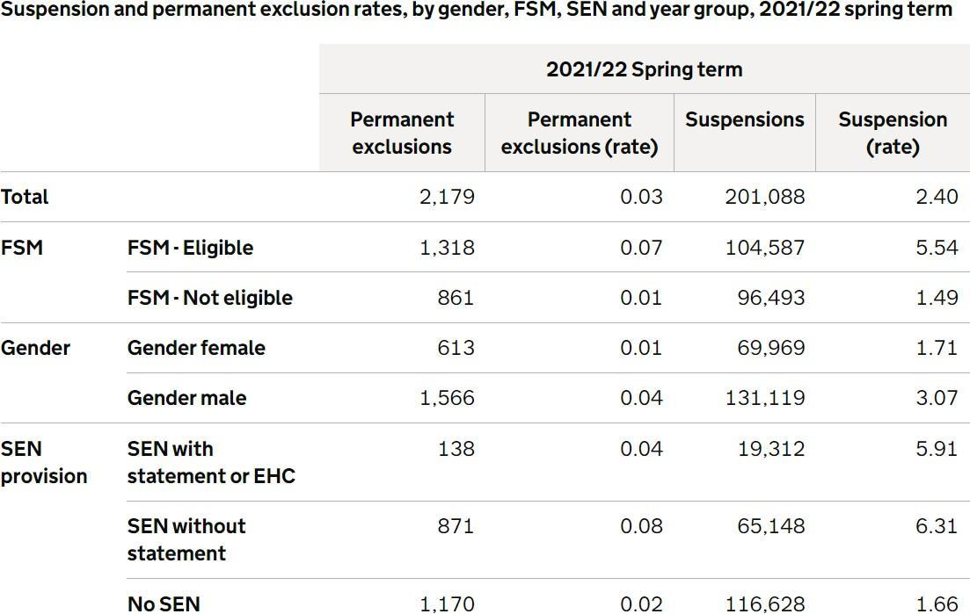

Schools should ensure that behaviour policies are fully inclusive, and that the needs of pupils with SEND are specifically considered during the development, implementation and evaluation of policy.
The engagement of pupils with SEND with the school’s behaviour policy must be carefully monitored, and where necessary, policy changes made or individual intervention/support provided.
Exclusion rates must be carefully monitored to ensure that this sanction is not being used disproportionately for pupils with SEND.
Where behaviour sanctions, including exclusion, are used for pupils with SEND, schools must ensure that the behaviours that have led to the application of sanctions are not due to the school failing to meet the academic, health, welfare or social needs of the pupils. Where necessary revisions to learning programmes, the provision of additional support, staff training or work with external agencies should be actioned.
Schools must engage with the Trust; local authority and other relevant agencies as soon as a child with SEND becomes at risk of exclusion.
The potential impact of exclusion on a pupil with SEND must be carefully considered before the sanction is used. If it is necessary to exclude a pupil with SEND, the school must liaise with all appropriate support agencies that are connected with the pupil and his/her family to ensure that welfare needs are met during the exclusion.
Before imposing a fixed-term or permanent exclusion, headteachers must consider the DfE document Suspension and Permanent Exclusion from maintained schools, academies and pupil referral units in England including pupil movement. September 2023
https://www.gov.uk/government/publications/school-exclusion

As well as having disproportionately high rates of exclusion, there are certain groups of pupils with additional needs who are particularly vulnerable to the impacts of exclusion. This includes pupils with EHC plans and looked after children. The head teacher should, as far as possible, avoid permanently excluding any pupil with an EHC plan or a looked after child.
The Trust will monitor exclusion rates across its schools, including those of pupils with SEND, and provide challenge and support where required
Timpson review of school exclusion
Timpson review of school exclusion: technical note

